***Attention students:***

***In order to demonstrate successful completion of all components in the project, please use screenshot(s) to show each completed action step as specified on the instructions page.***

**Identity and Access Management**

1. **Proof of Assigned roles and AD assignments**
   1. Andrew
   2. Chris
   3. Karl
   4. Lora
   5. Neelima
   6. Neha
   7. Seth
   8. Srinadh
   9. Tom
   10. Winifred

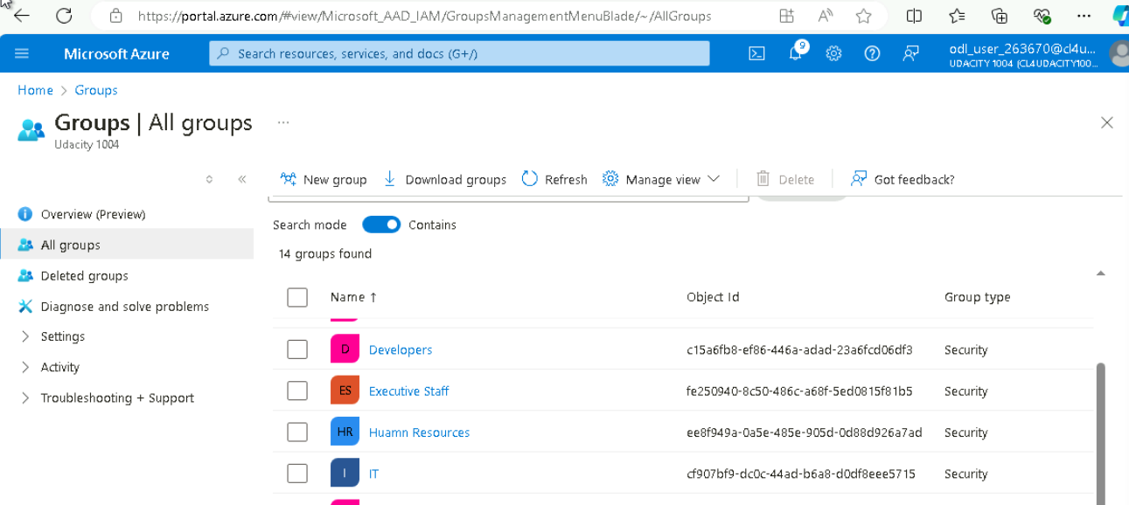

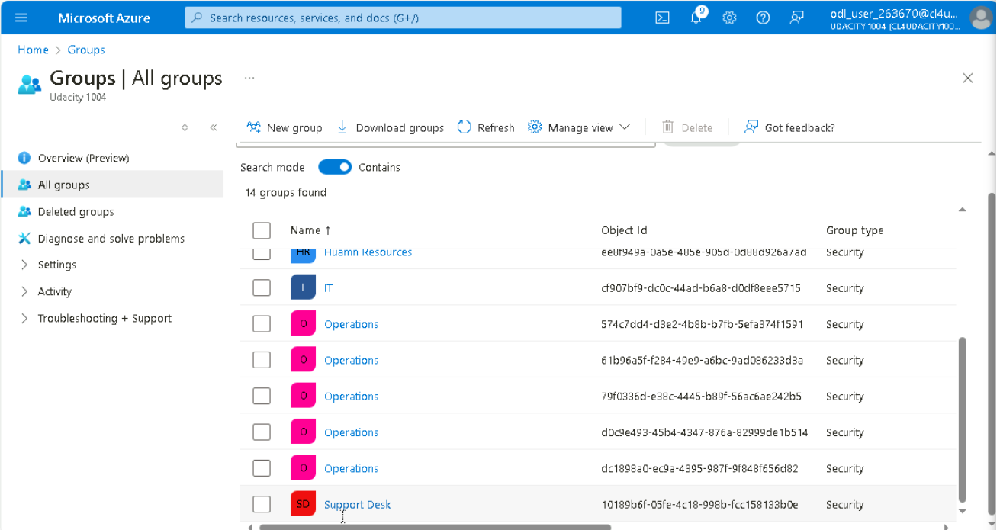

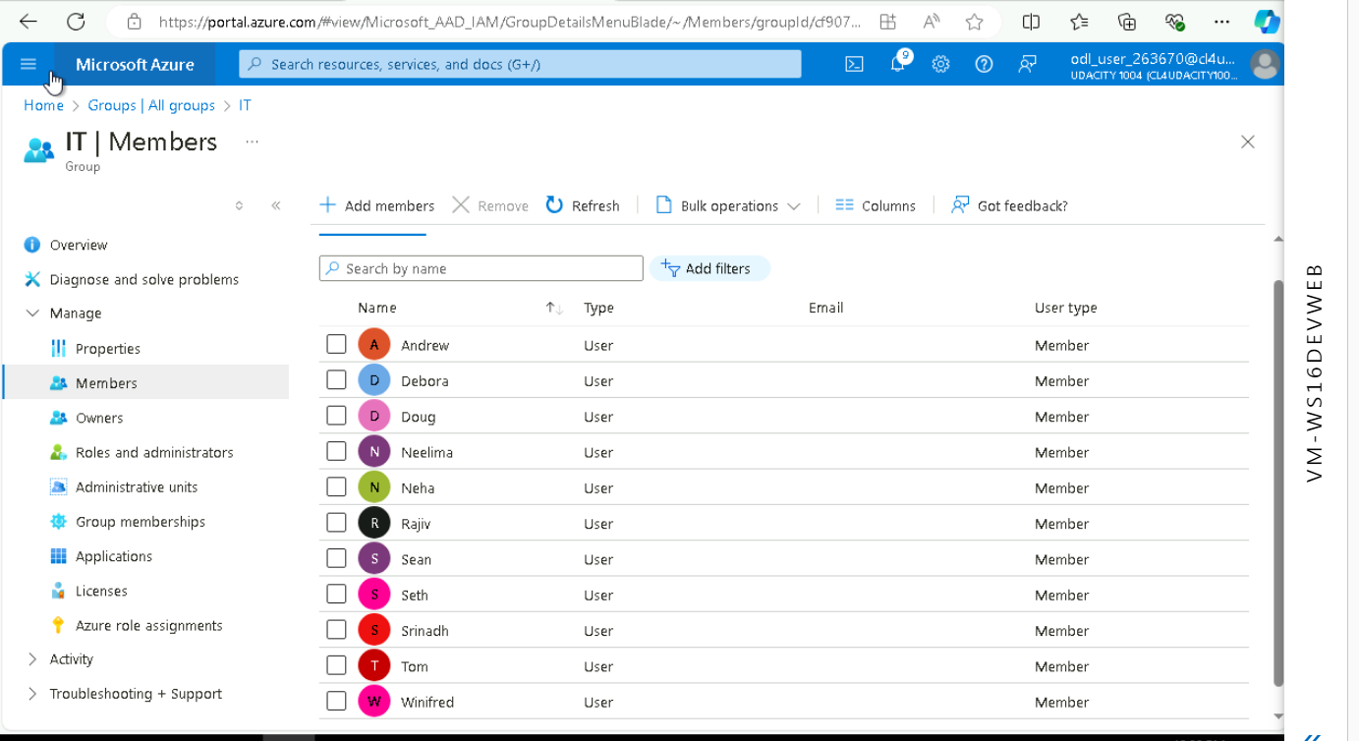

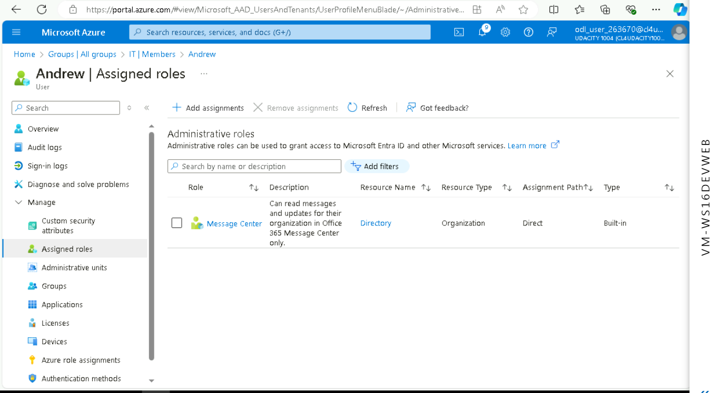

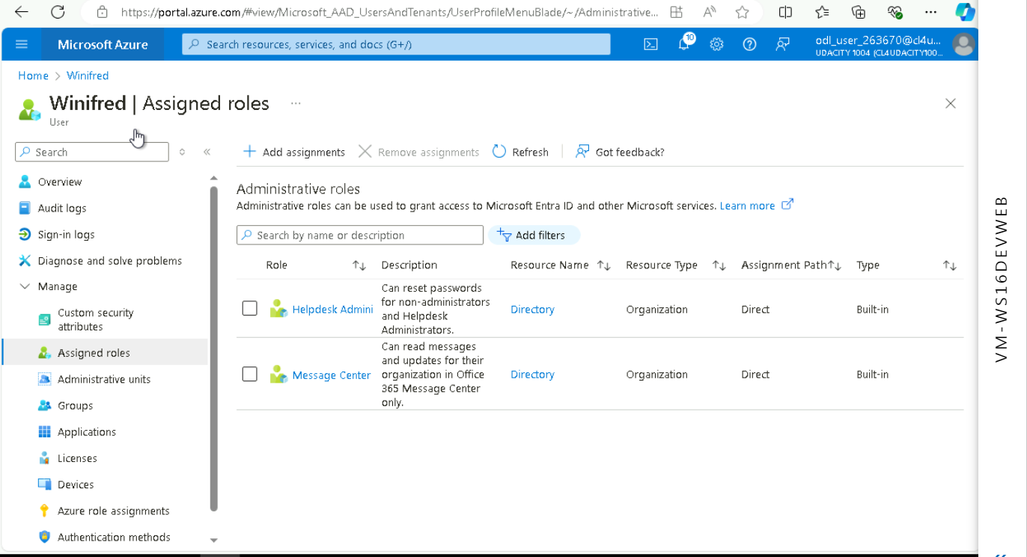

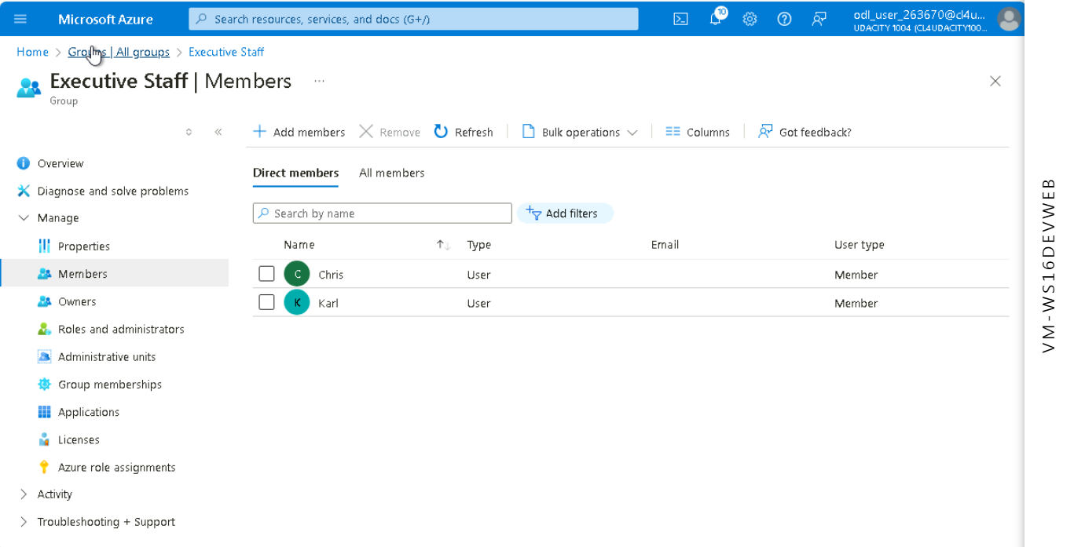

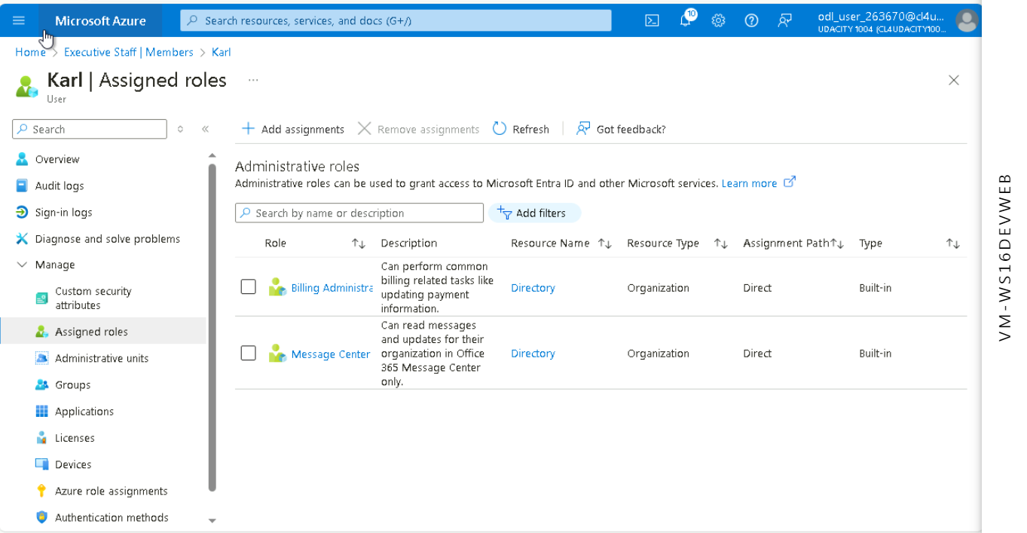

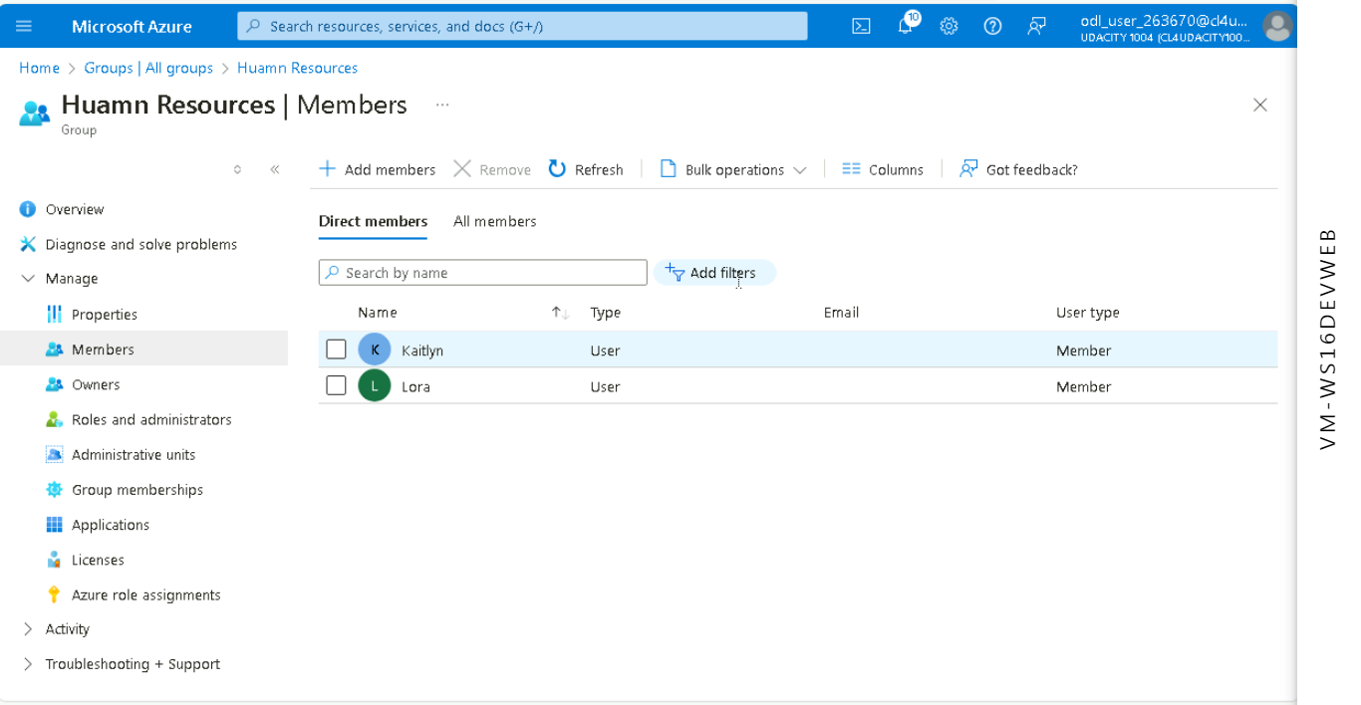

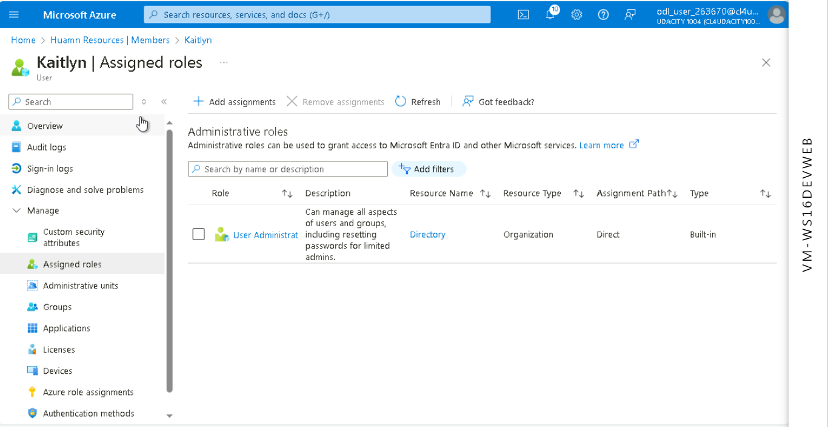

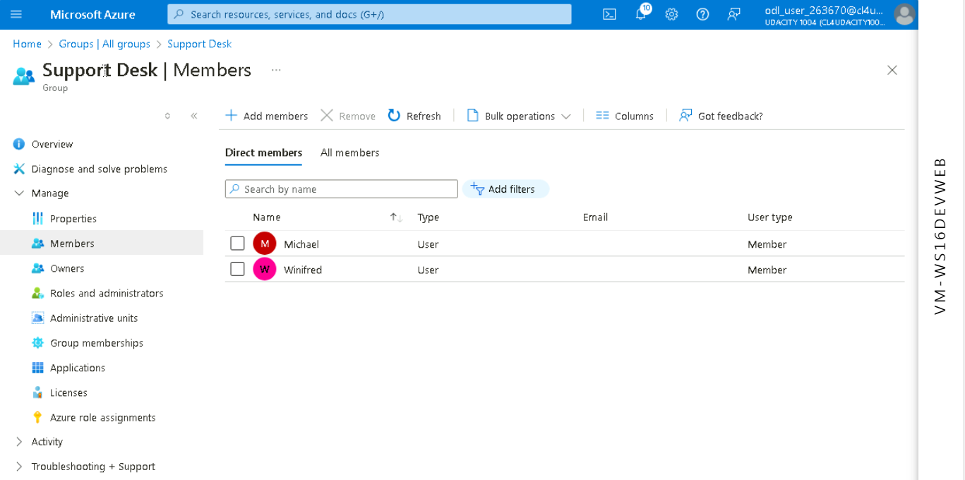

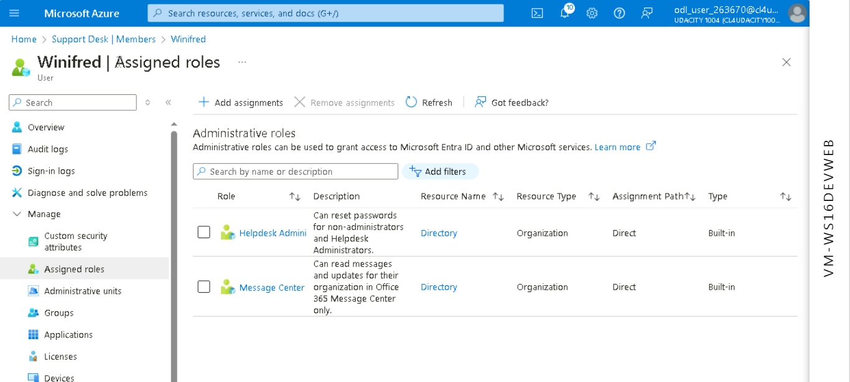

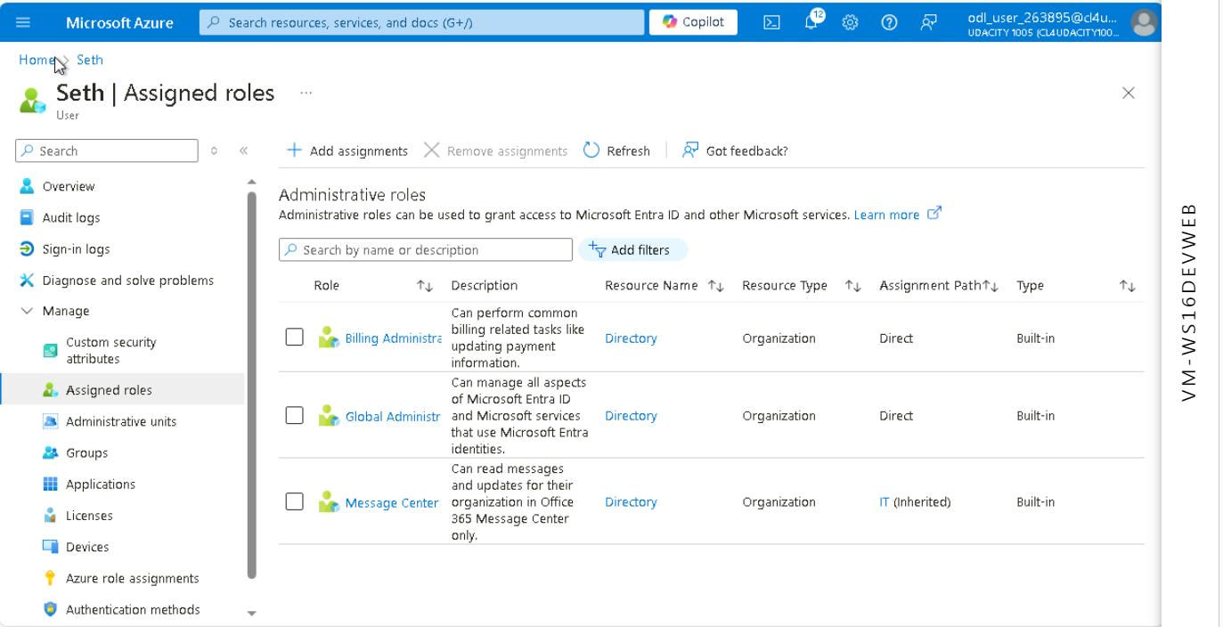

1. **Proof of Global Administrator setting with duration, eligibility, expiration**

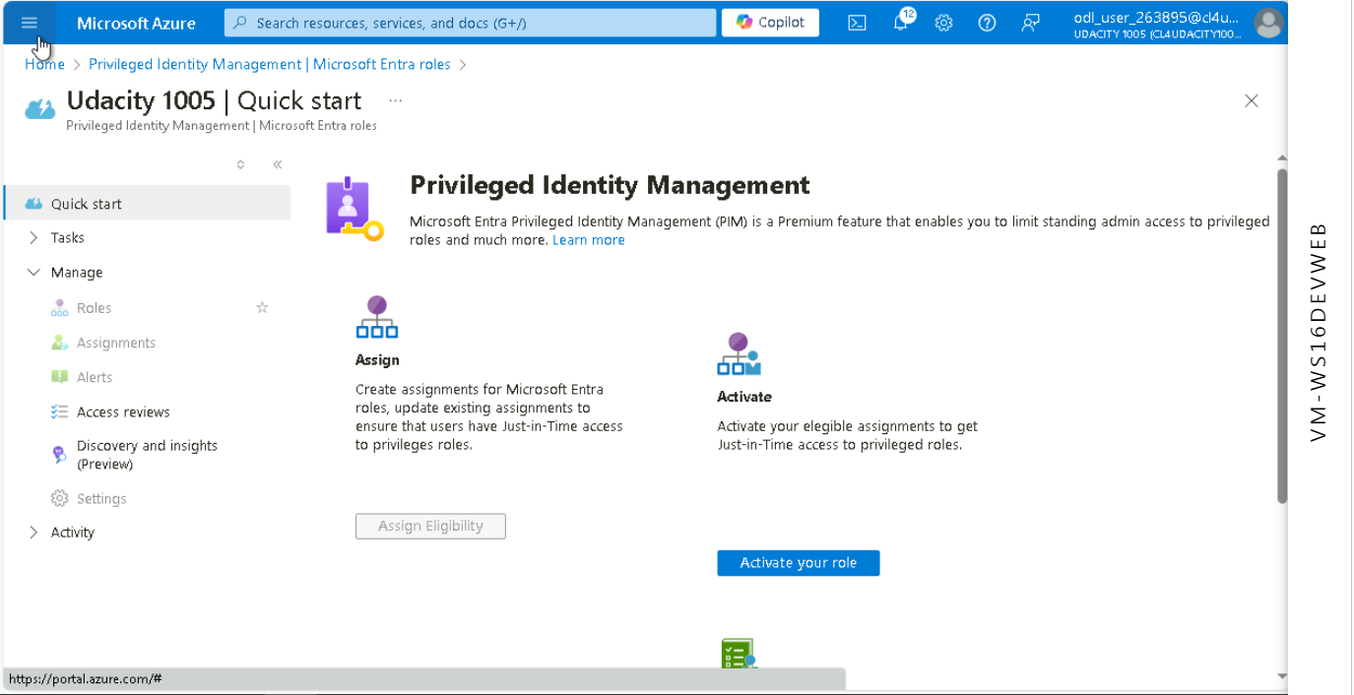

Function not available on Udacity Environment/Account

1. **Proof of Conditional Access policy all users**

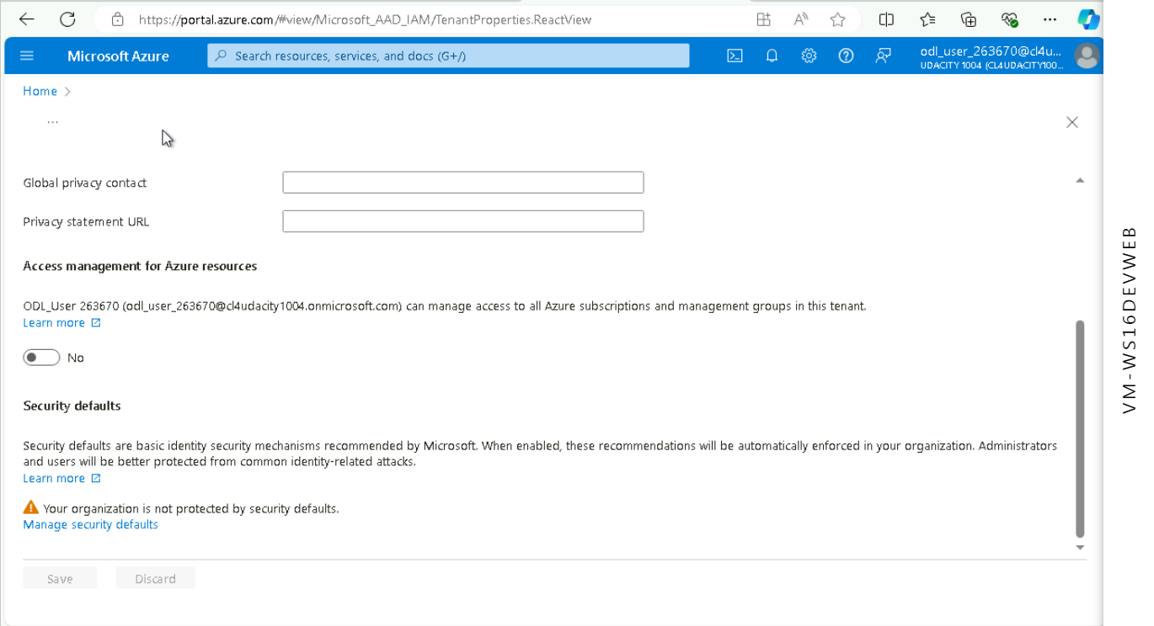

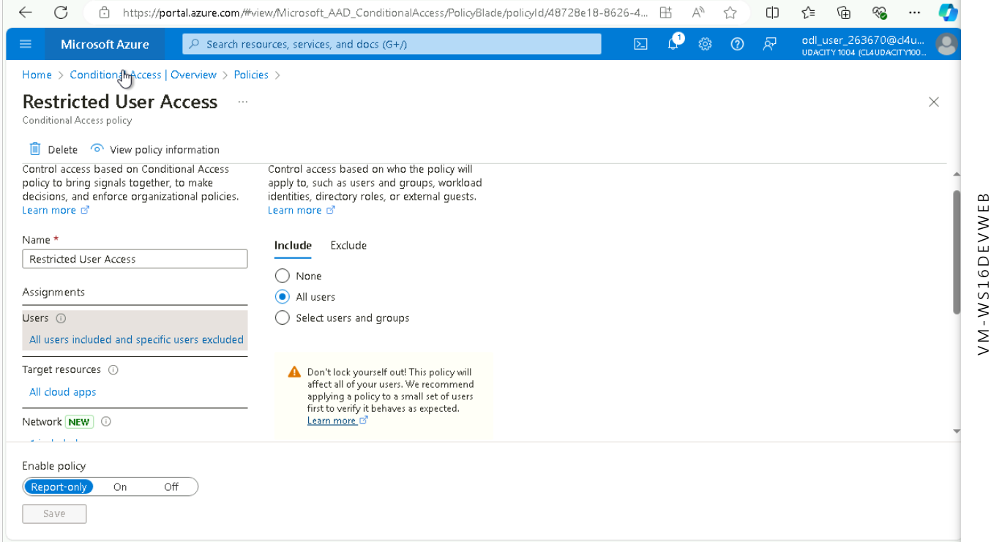

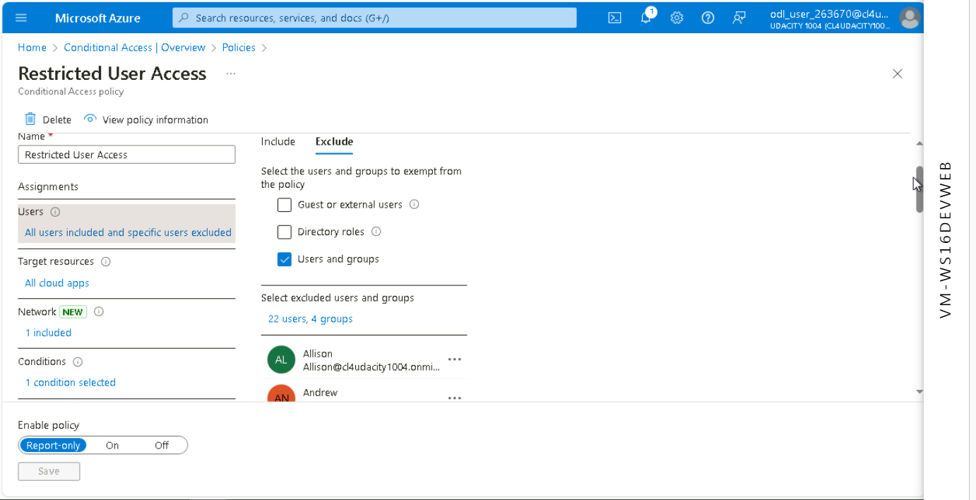

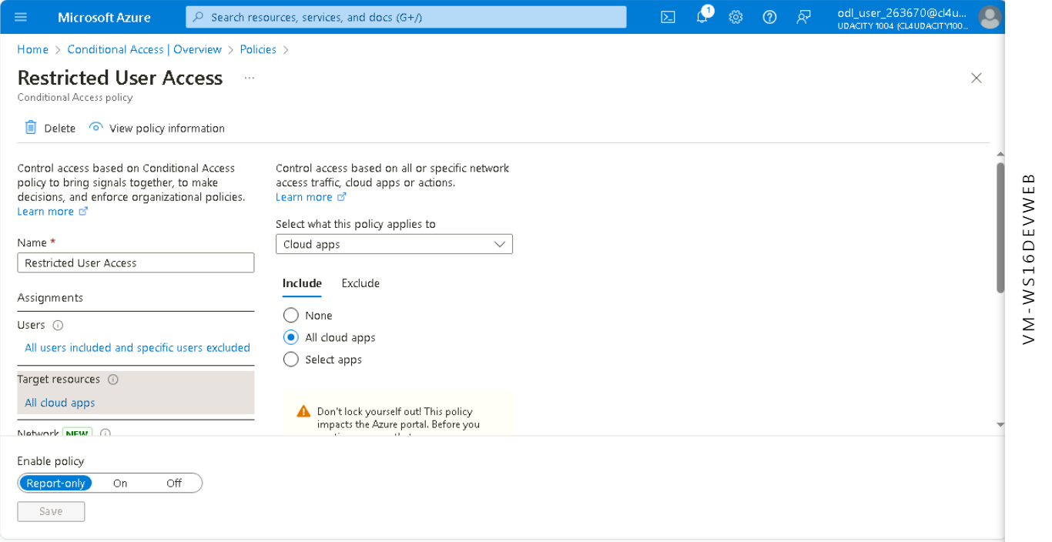

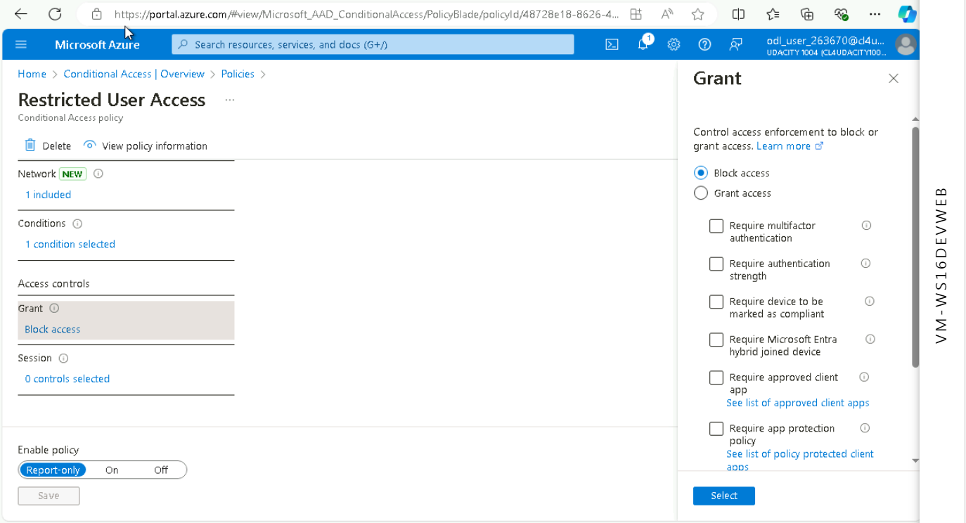

1. **Proof of Multi-factor authentication(14 days, Charlotte office info)**

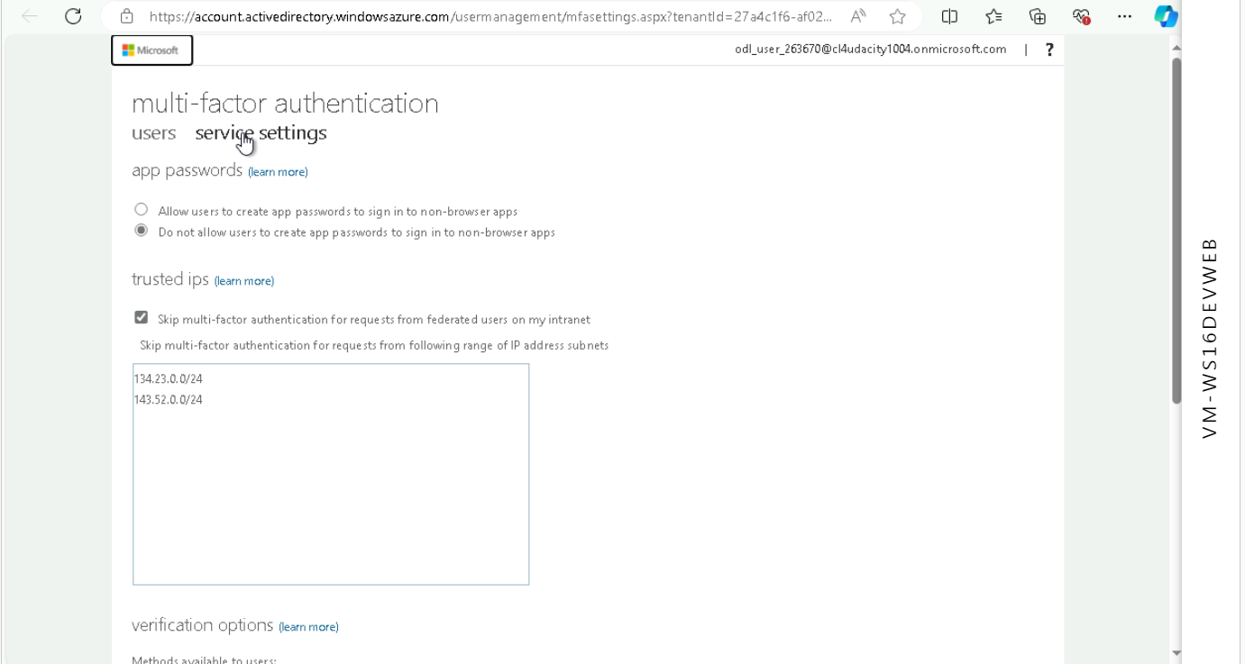

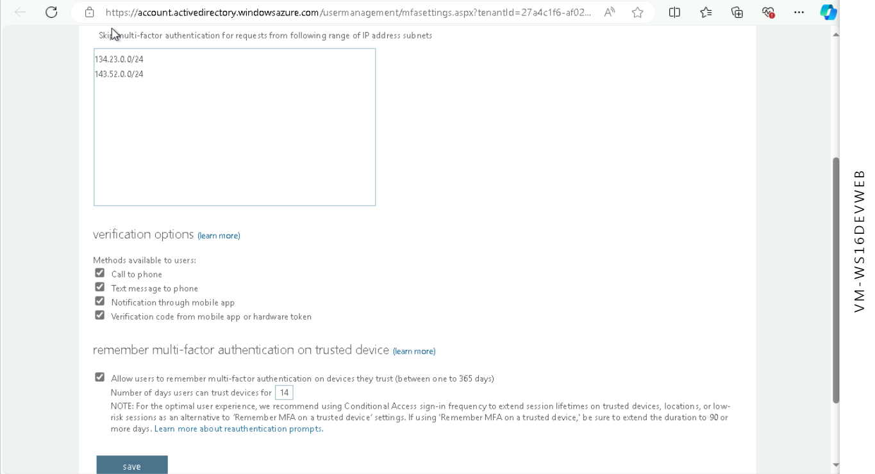

**Network Security**

1. **Bastion overview**

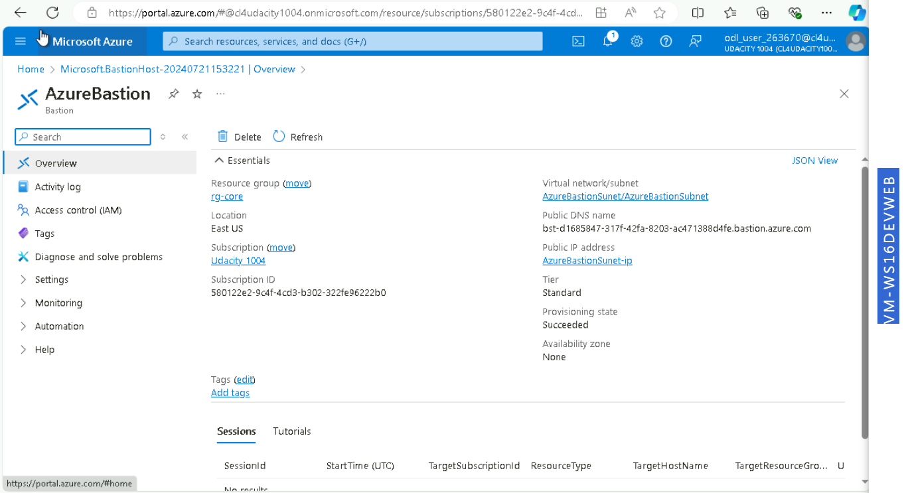

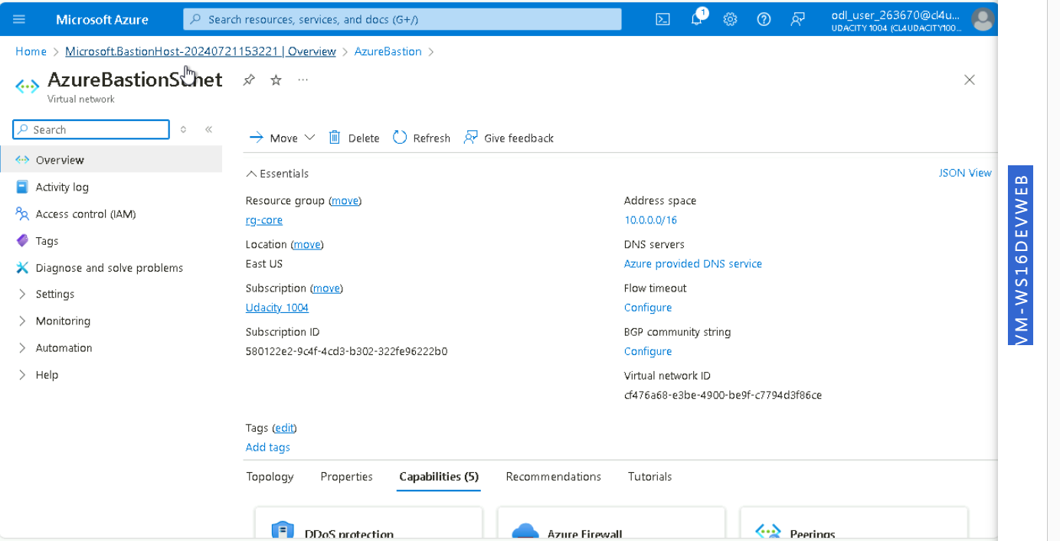

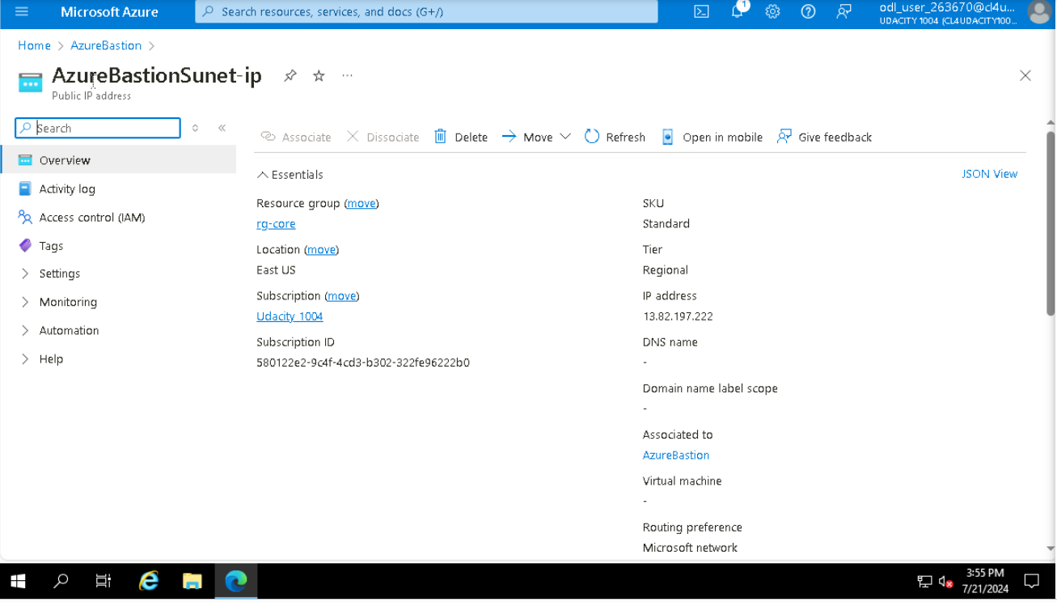

1. **Proof of public IP addresses removed**

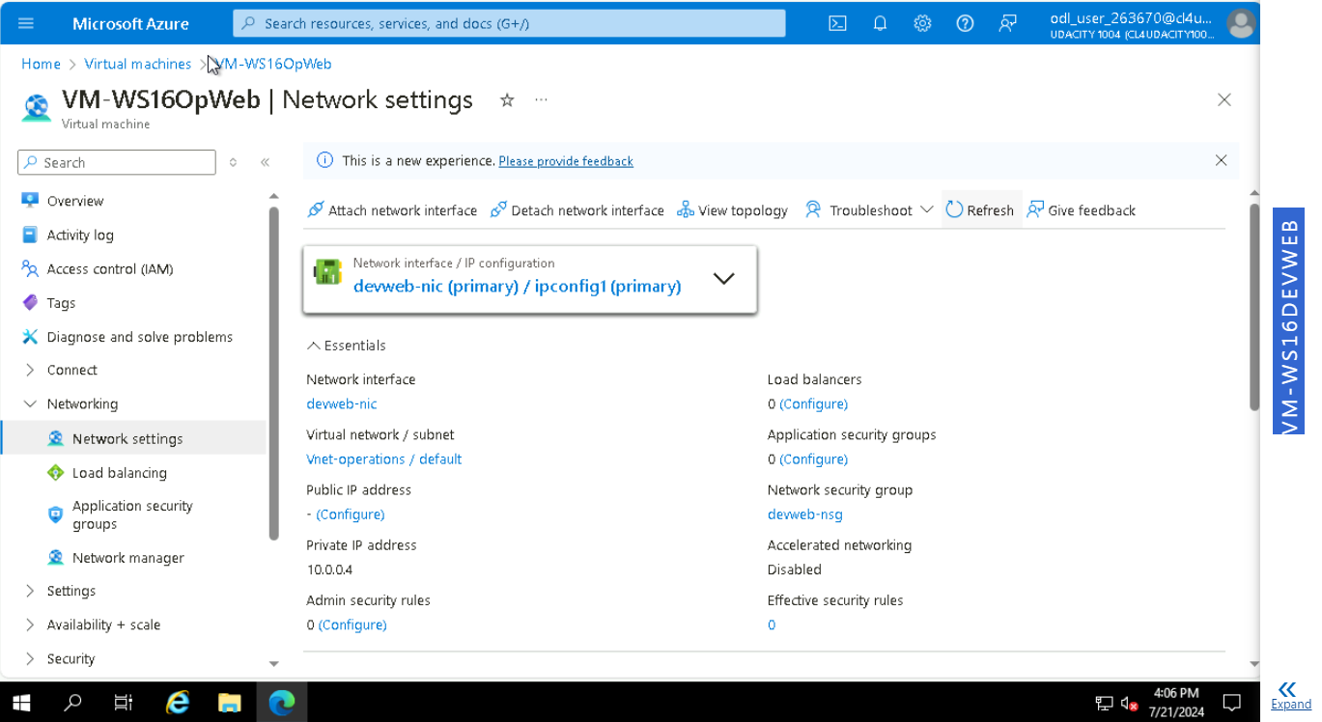

**Data and Encryption**

1. Proof of Encryption types for VM ( devapp,OpWeb,HRL-App,OPApp, HRL-Web)

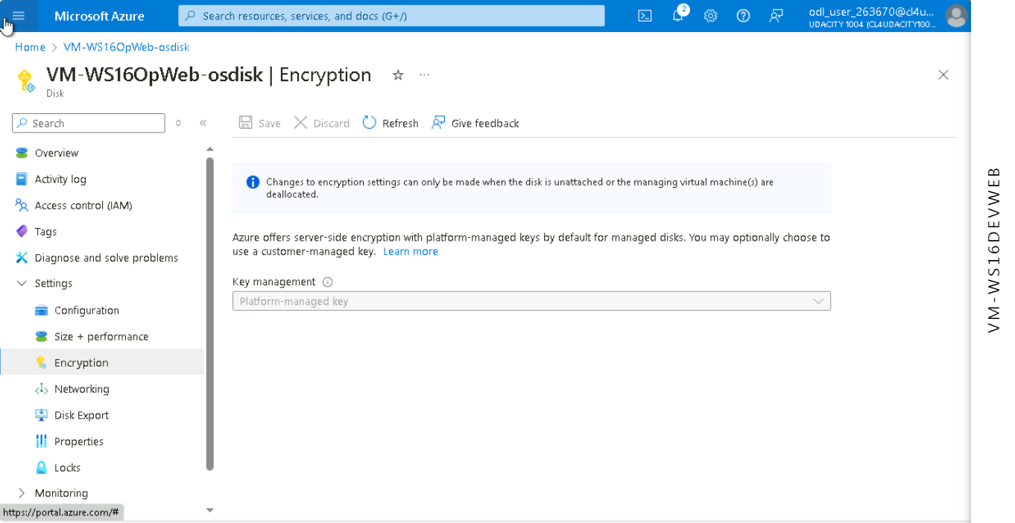

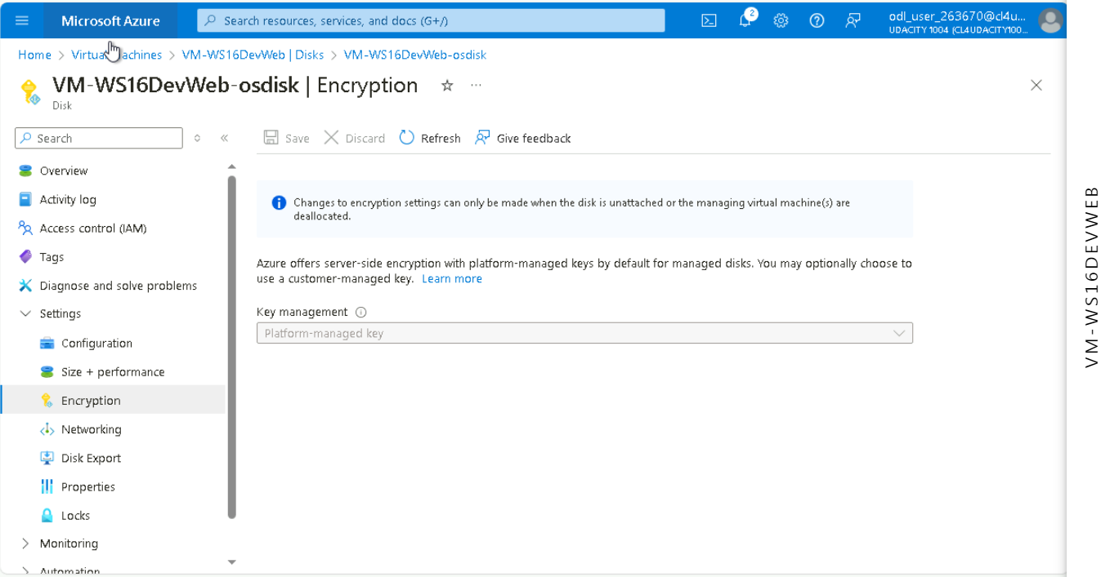

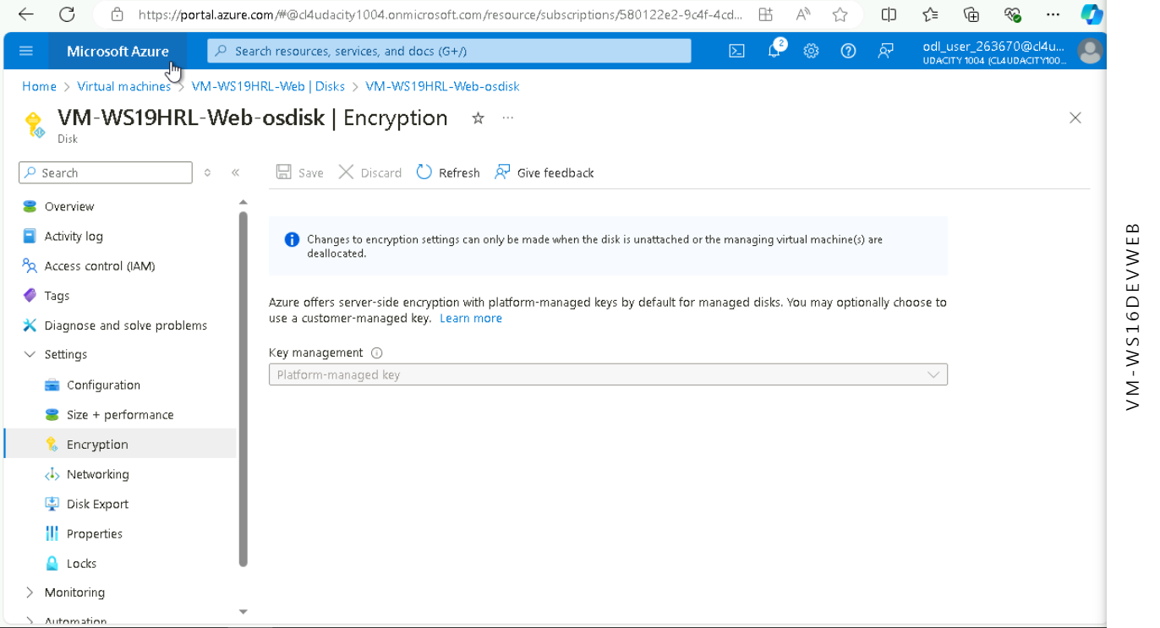

1. Firewalls and virtual networks page

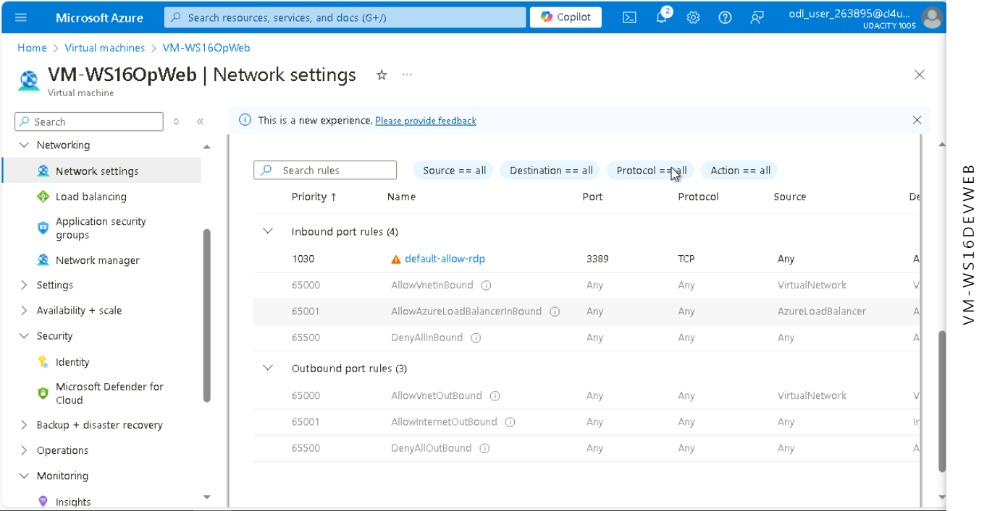

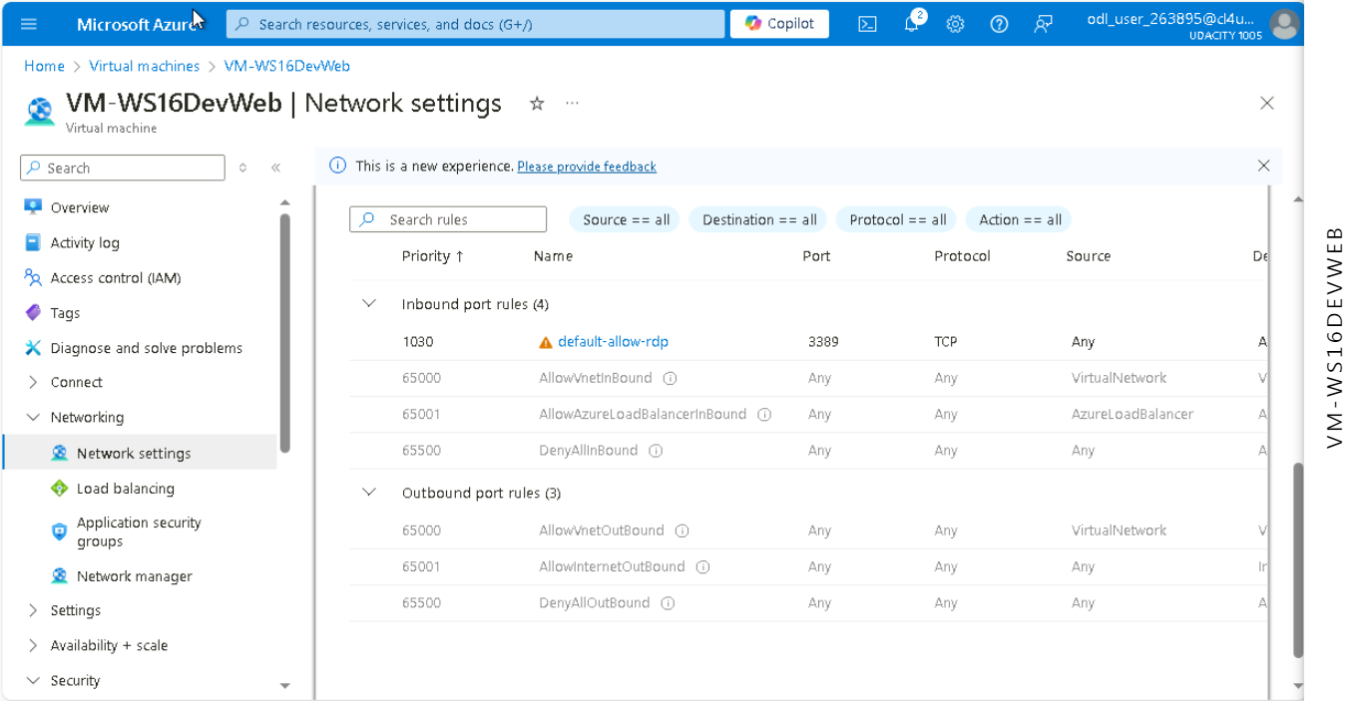

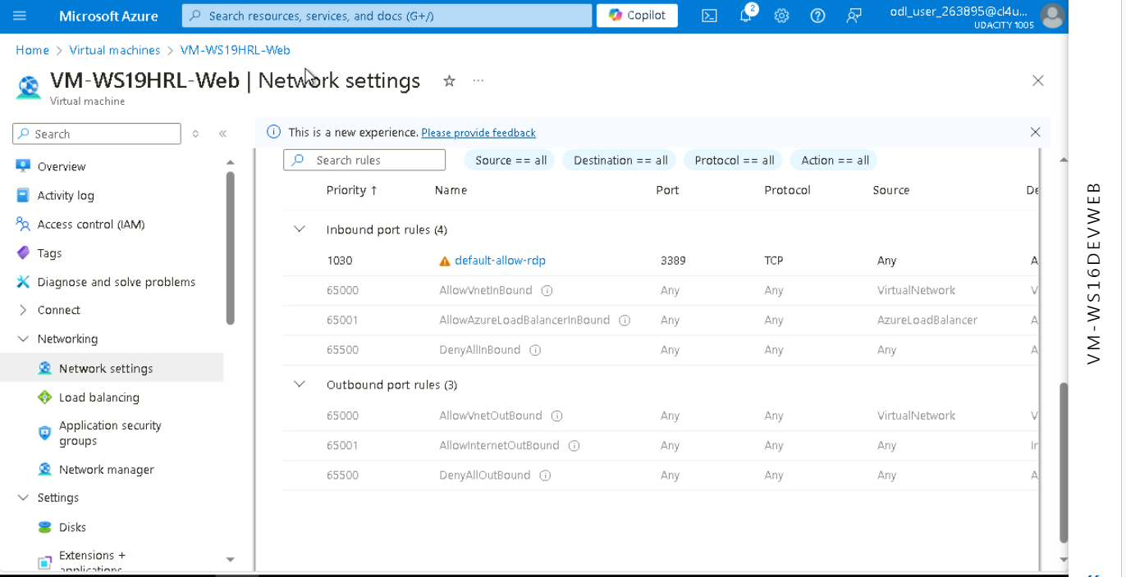

1. Proof of no public access and TLS for SQL servers(prod, dev)

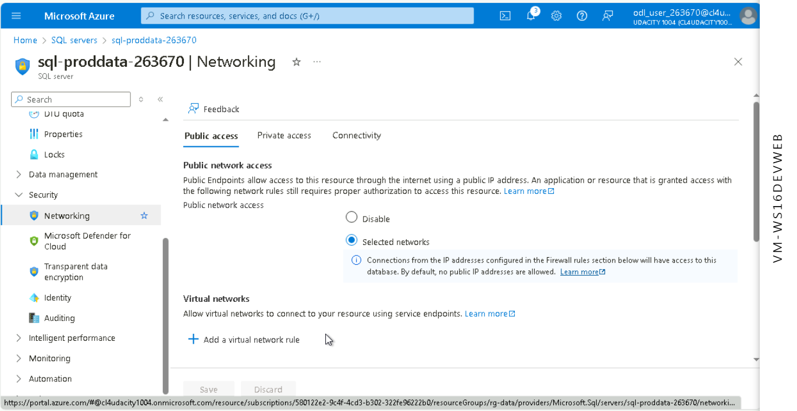

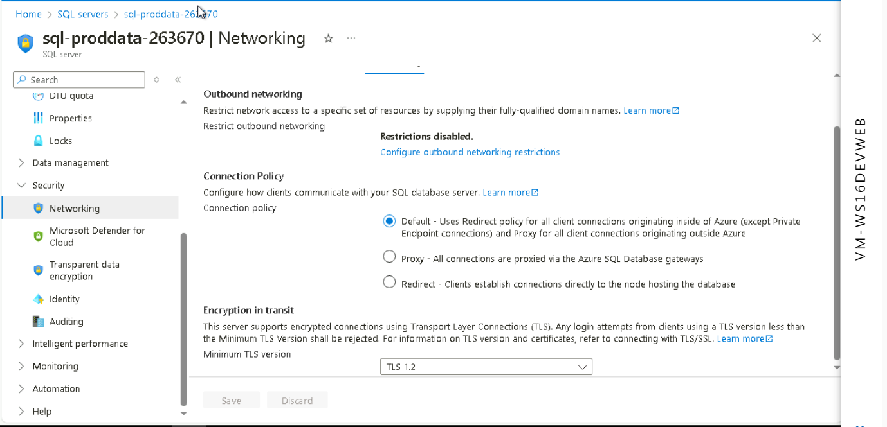

1. Proof of Azure Defender SQL server enabled(prod, dev)

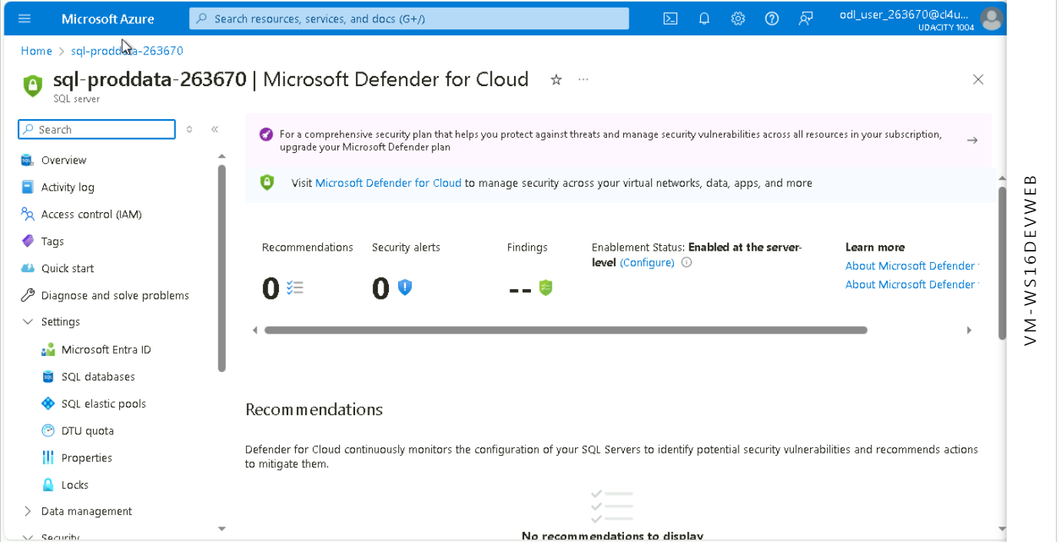

1. Proof of Azure AD authentication for SQL enabled(prod, dev)

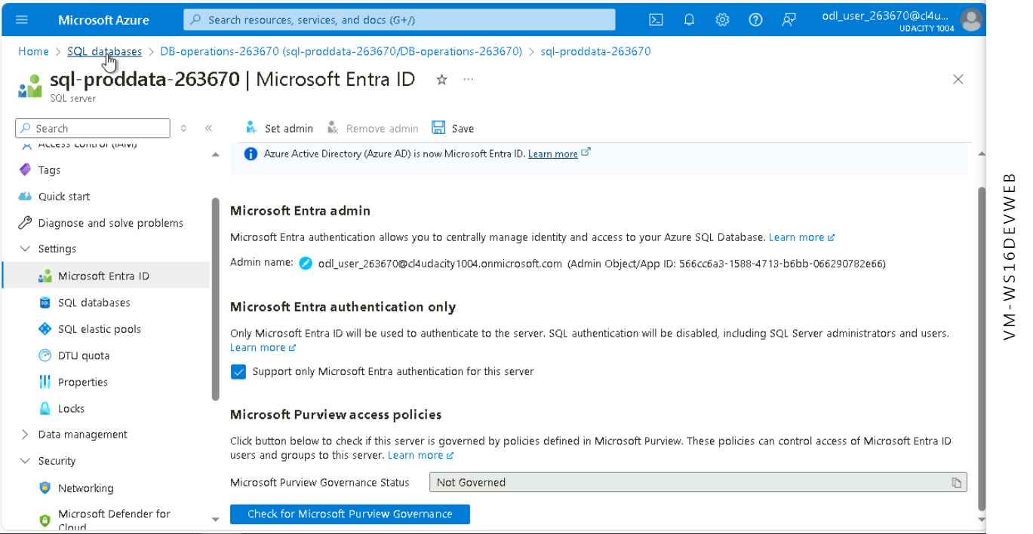

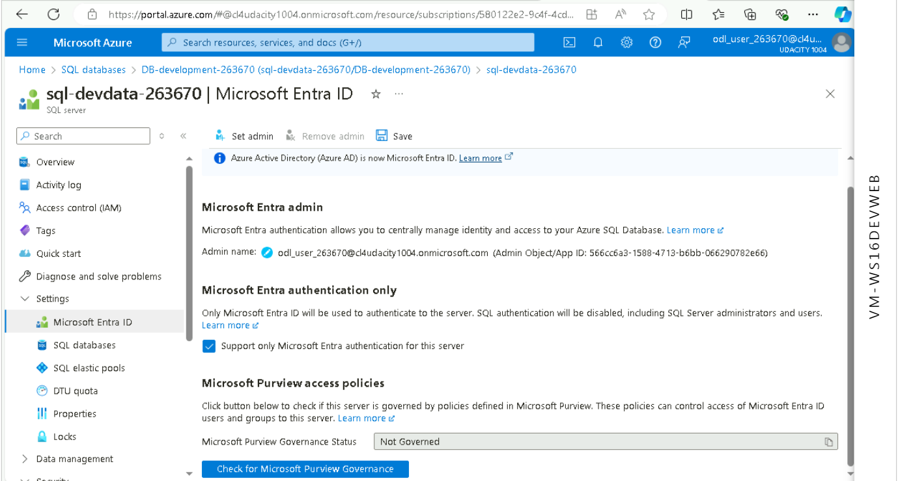

**Cloud Protection**

1. Proof of IaaSAntimalware enabled ( devapp,OpApp,HRL-Web, HRL-App,OpWeb)

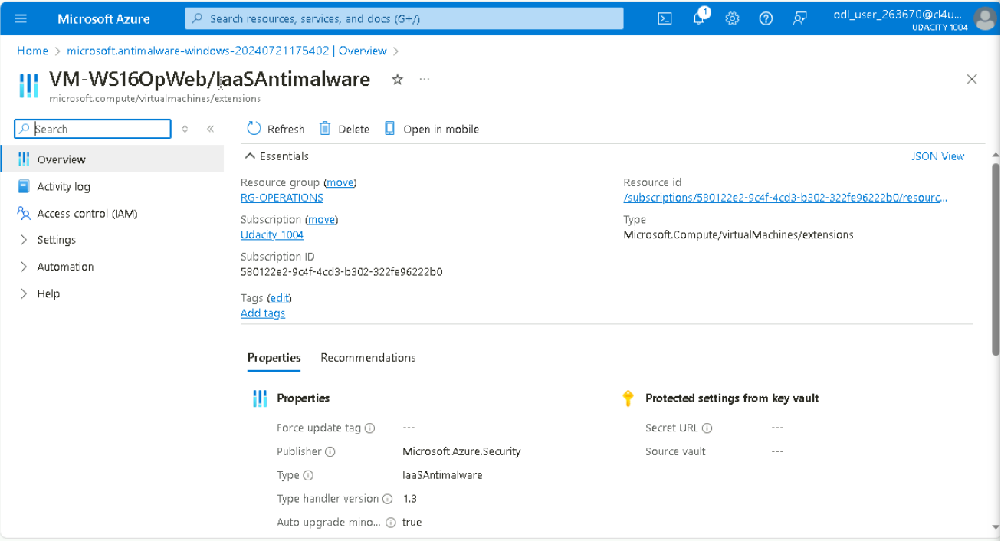

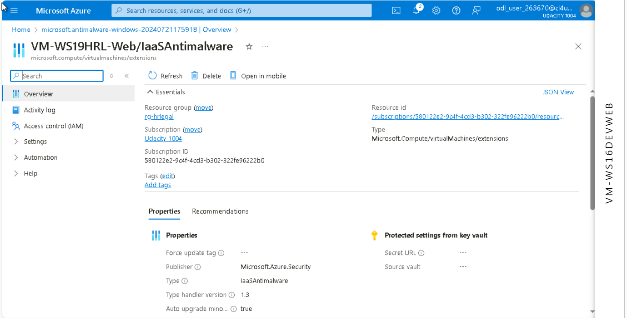

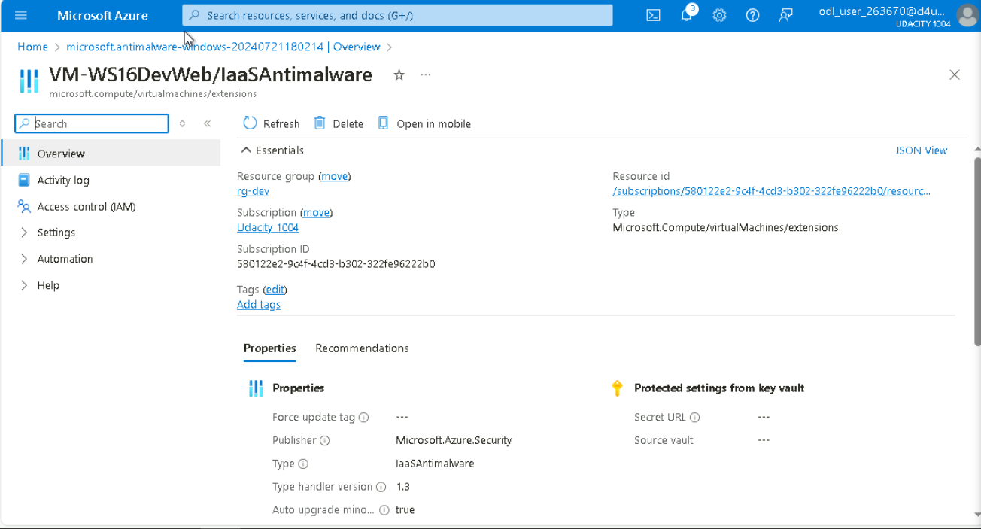

1. Recommendations

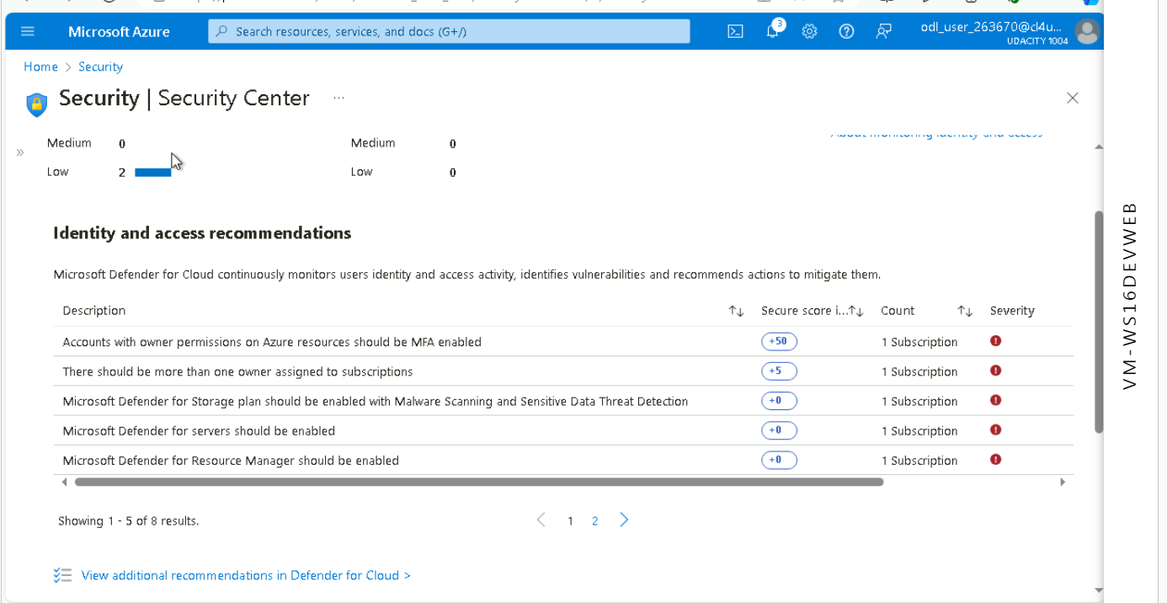

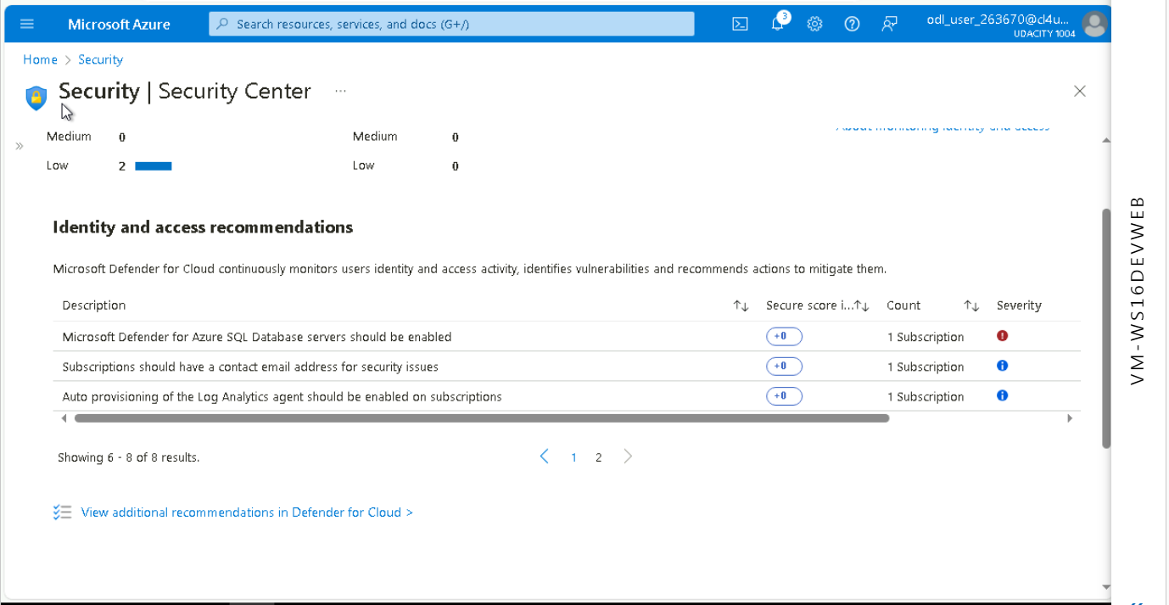

**Accounts with Owner Permissions on Azure Resources Should be MFA Enabled**

* **Secure Score Impact:** +50
* **Count:** 1 Subscription
* **Severity:** High
* **Justification:** Multi-Factor Authentication (MFA) significantly enhances security by requiring additional verification steps, making it much harder for unauthorized users to gain access. Given the high secure score impact and severity, enabling MFA for accounts with owner permissions is crucial to protect critical resources.

**There Should be More Than One Owner Assigned to Subscriptions**

* **Secure Score Impact:** +5
* **Count:** 1 Subscription
* **Severity:** High
* **Justification:** Having multiple owners assigned to subscriptions ensures continuity and reduces the risk of losing access due to a single point of failure. This practice is essential for maintaining access management and operational resilience.

**Subscriptions Should Have a Contact Email Address for Security Issues**

* **Secure Score Impact:** +0 (however, crucial for communication)
* **Count:** 1 Subscription
* **Severity:** Medium
* **Justification:** Having a contact email address ensures that security notifications and alerts are promptly received, allowing for quicker response to potential security incidents. This measure helps in maintaining an active communication channel for security issues.

**Monitoring**

1. Proof of Azure SQL auditing with Log analytics (devdata,proddata)

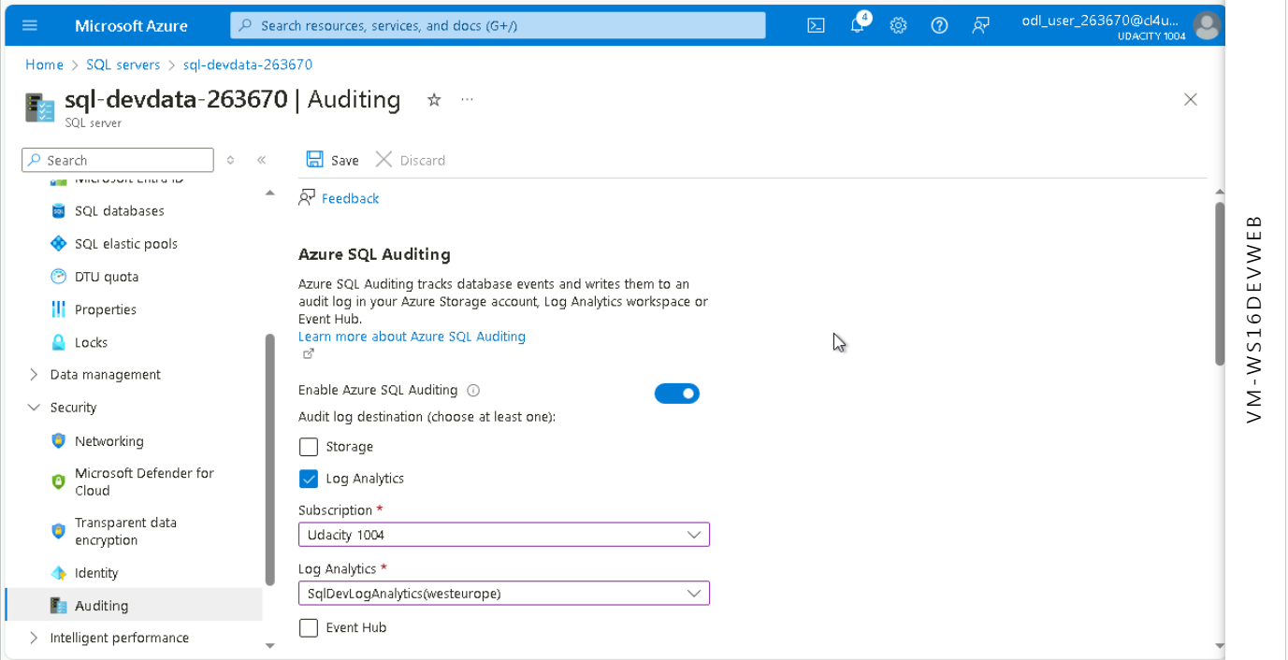

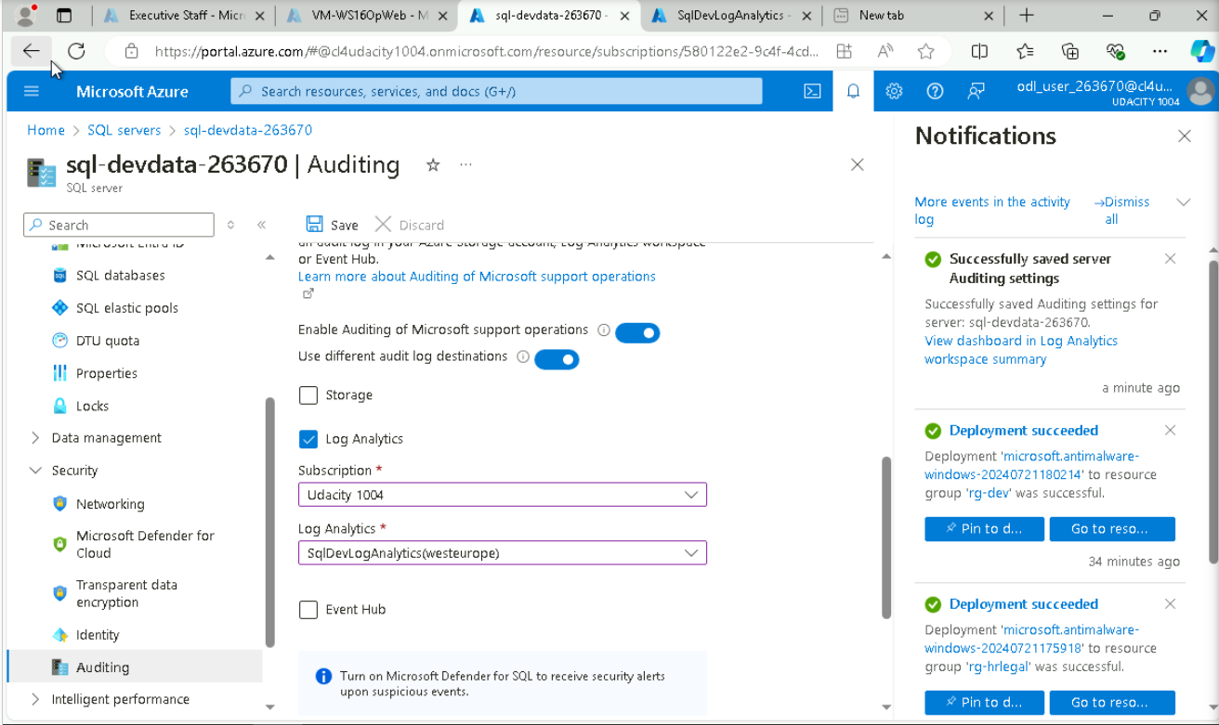

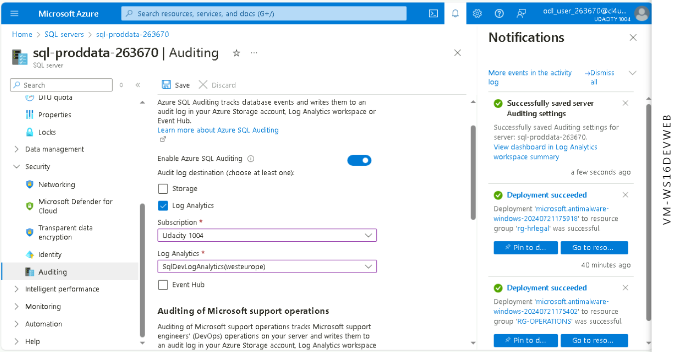

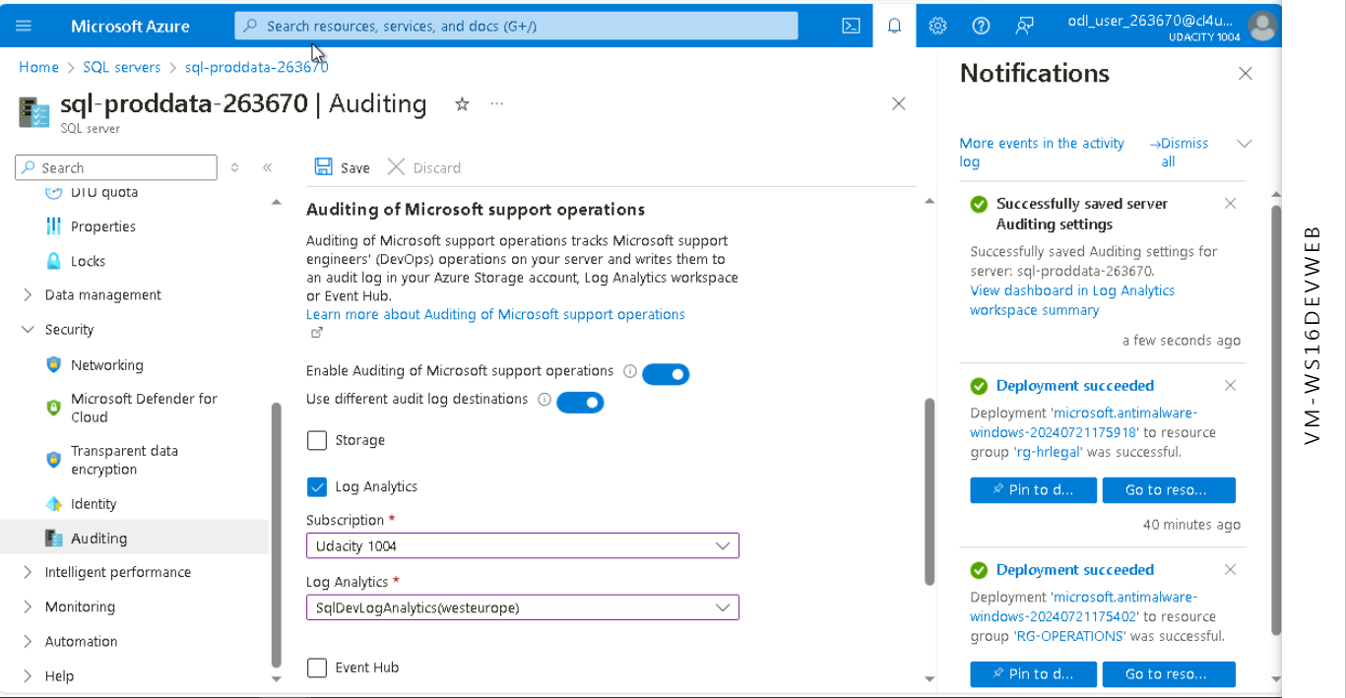

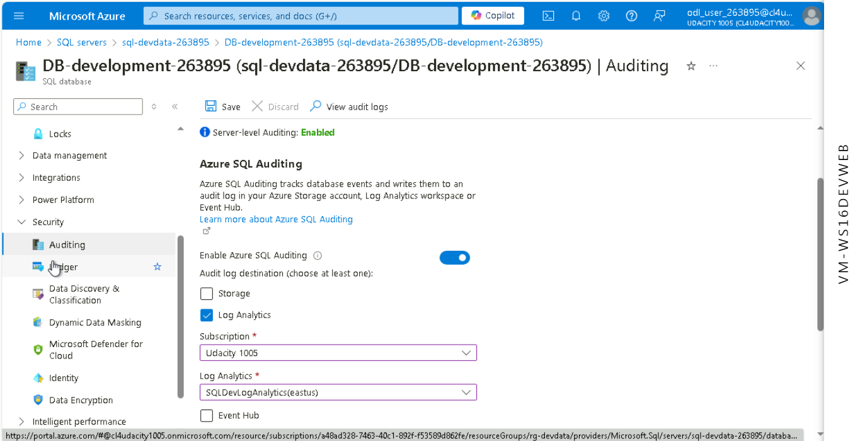

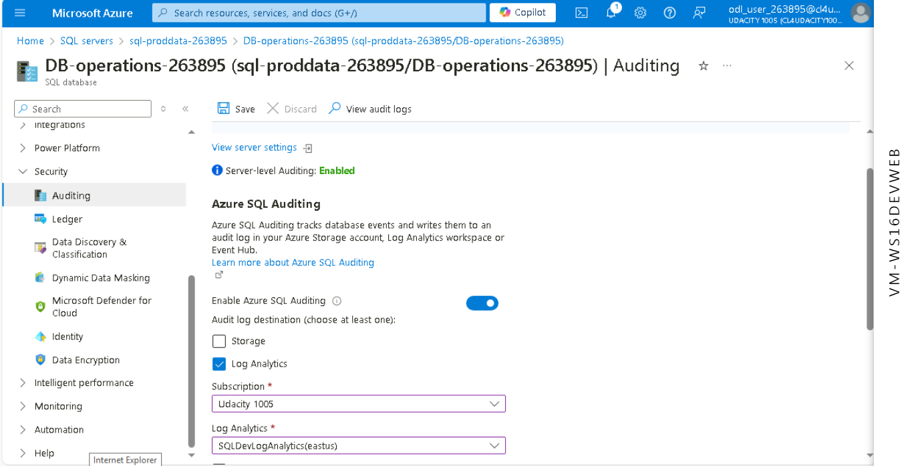

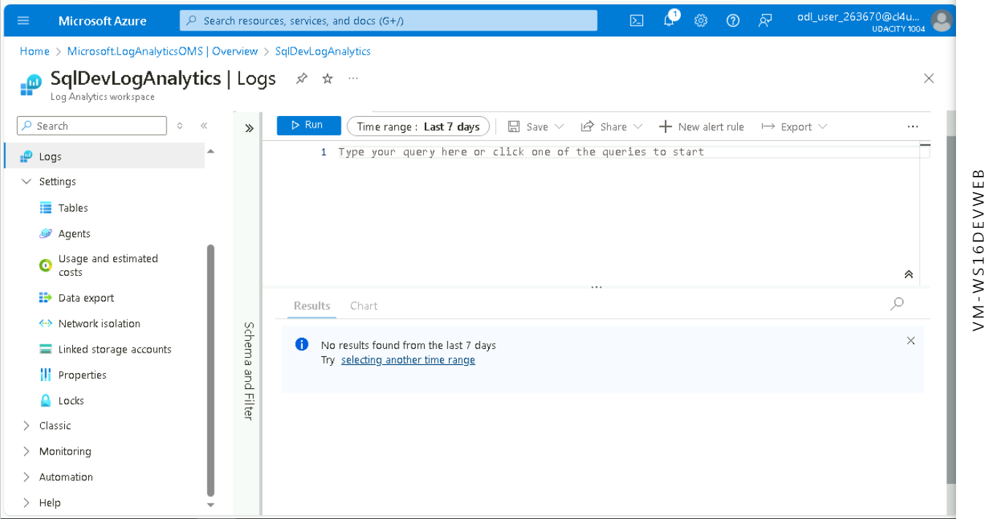

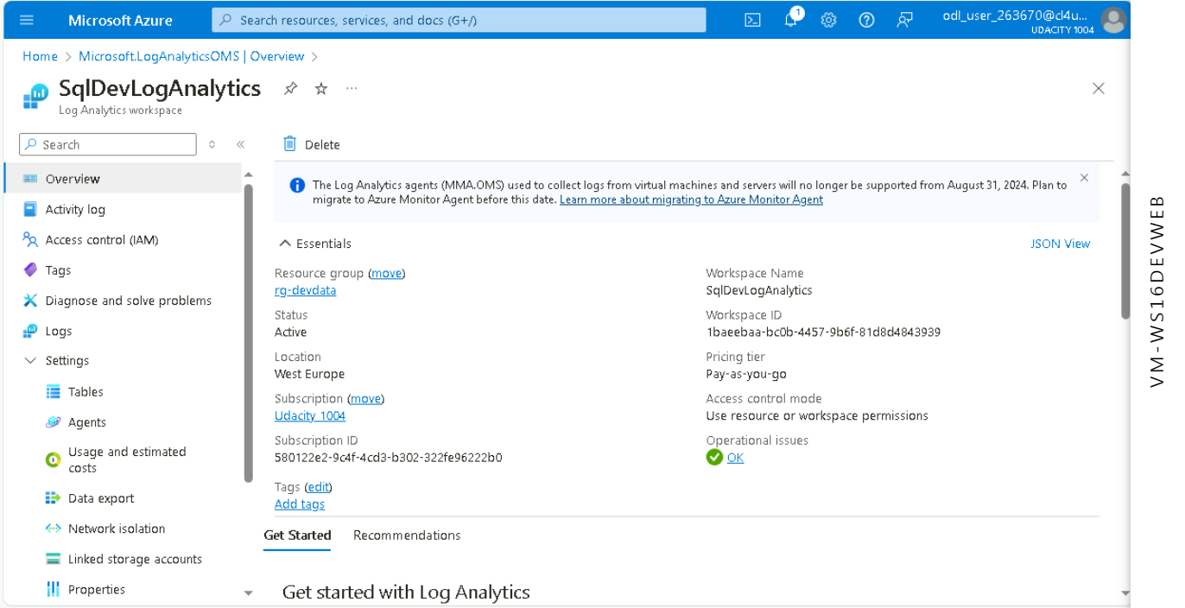

1. **Proof of Sentinel connectors (2+)**

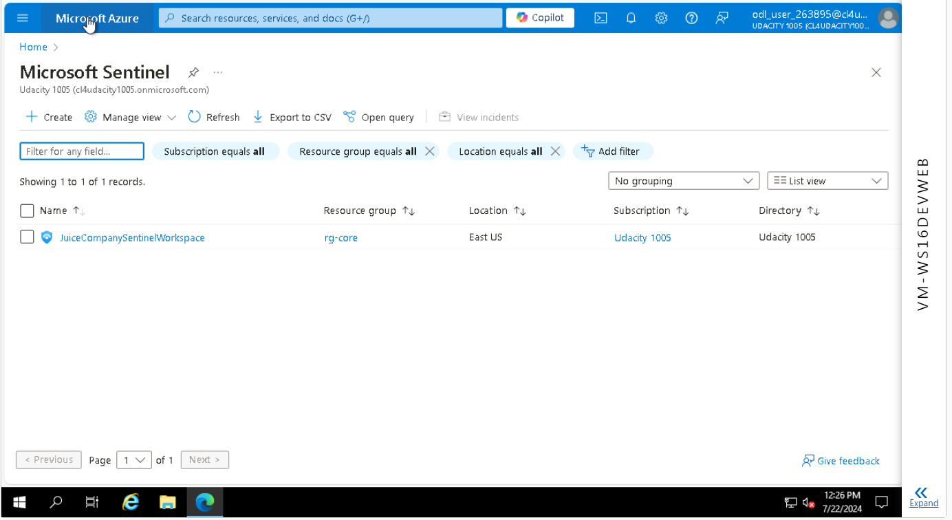

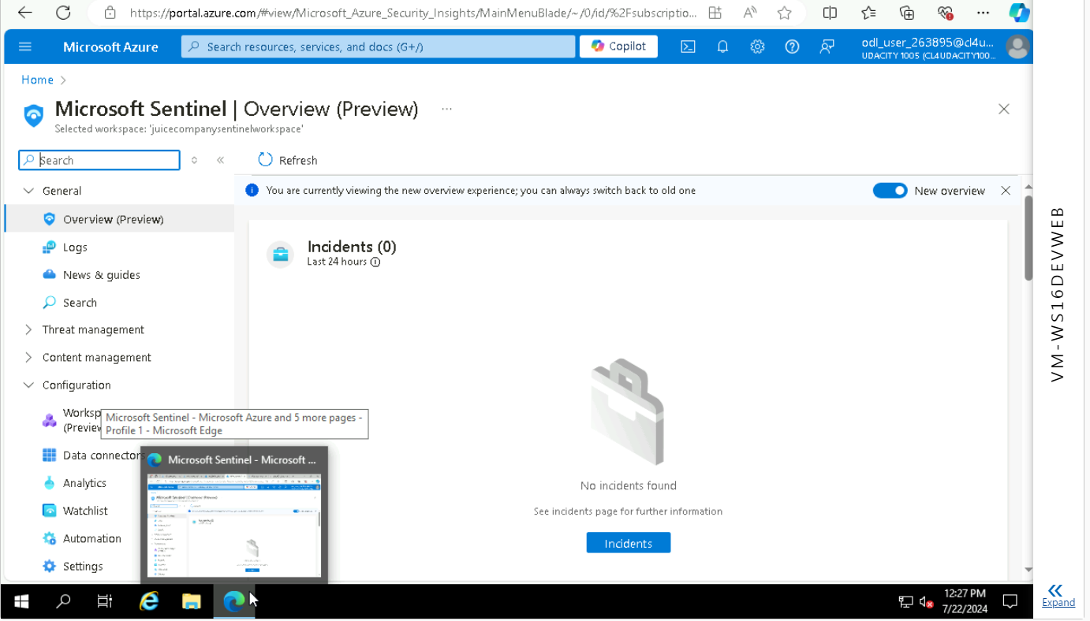

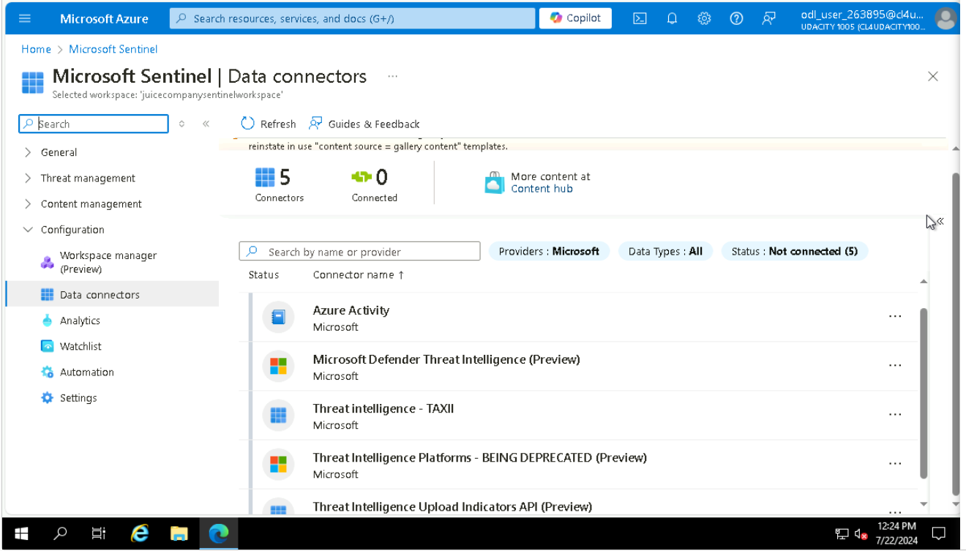

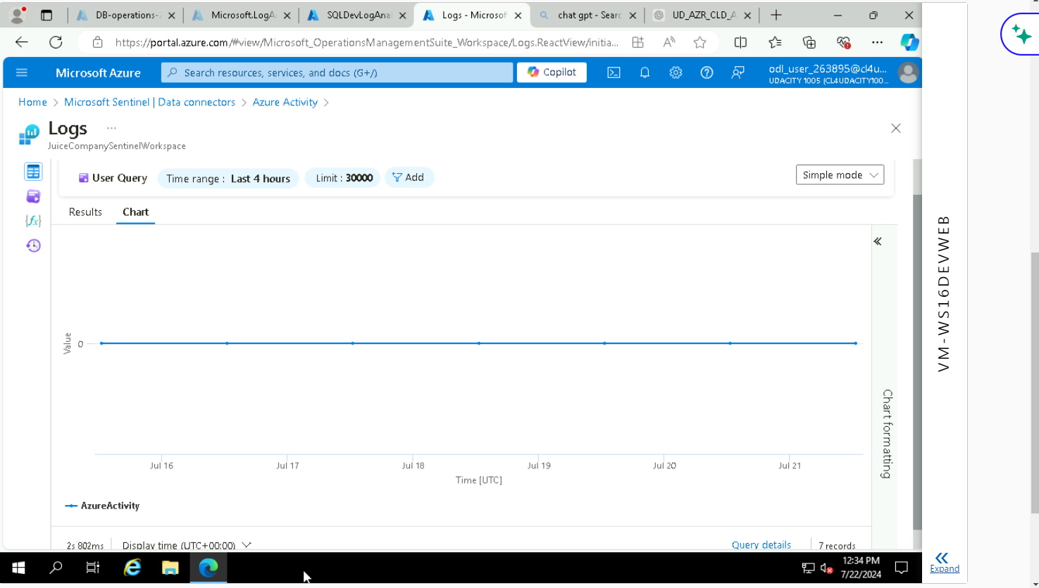

**Compliance**

1. **Proof of NIST SP 800-53 rev4 policy added**

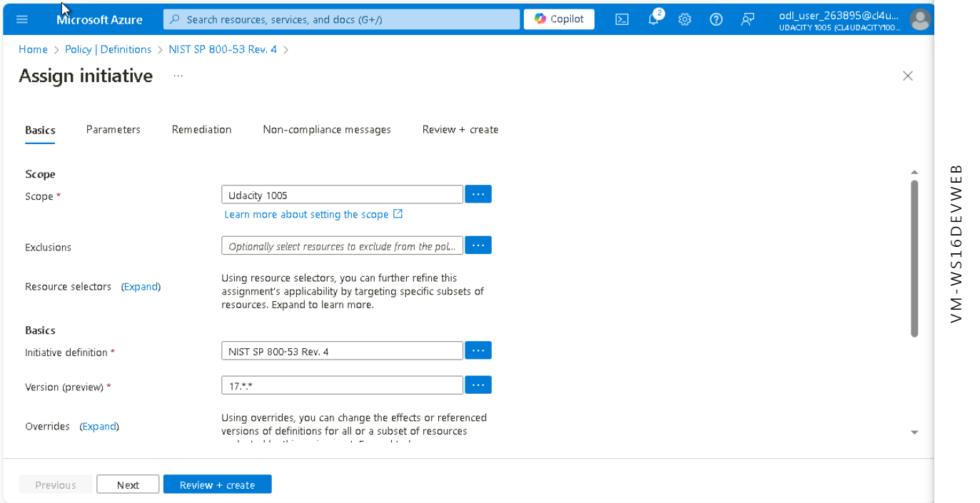

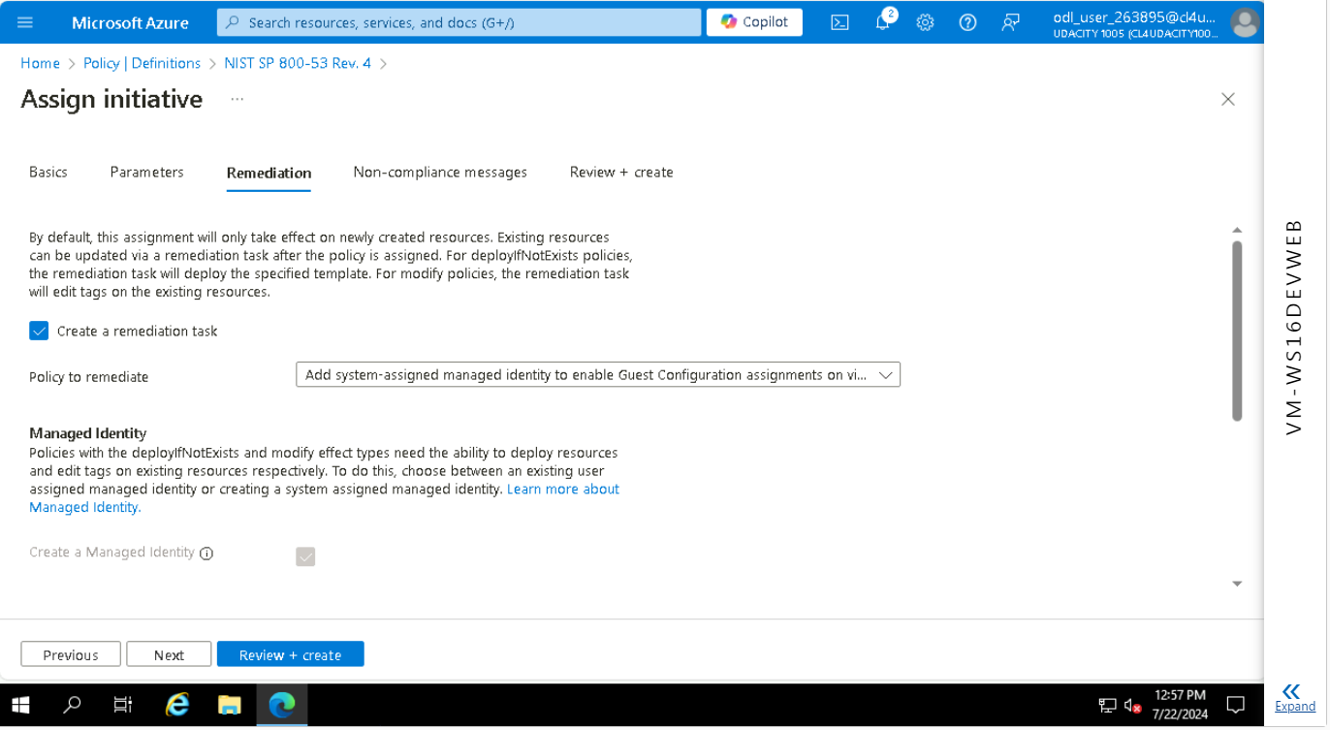

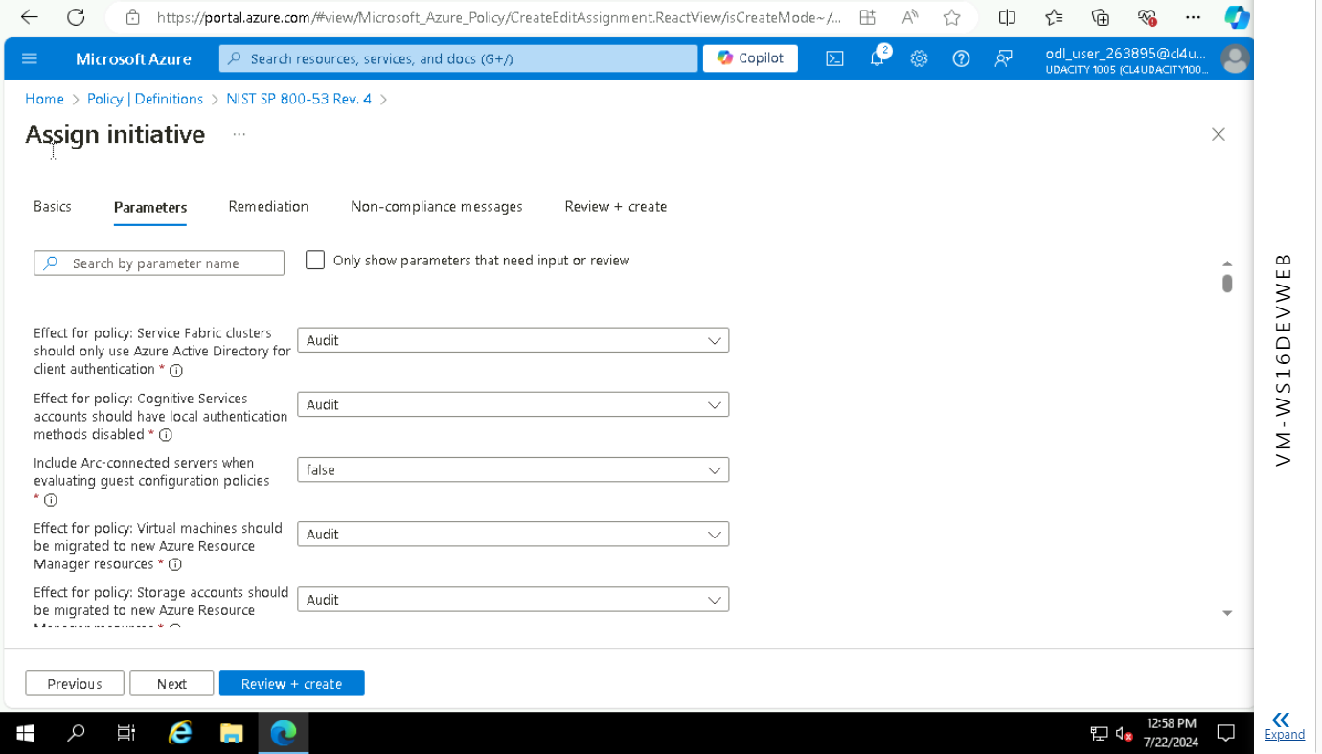

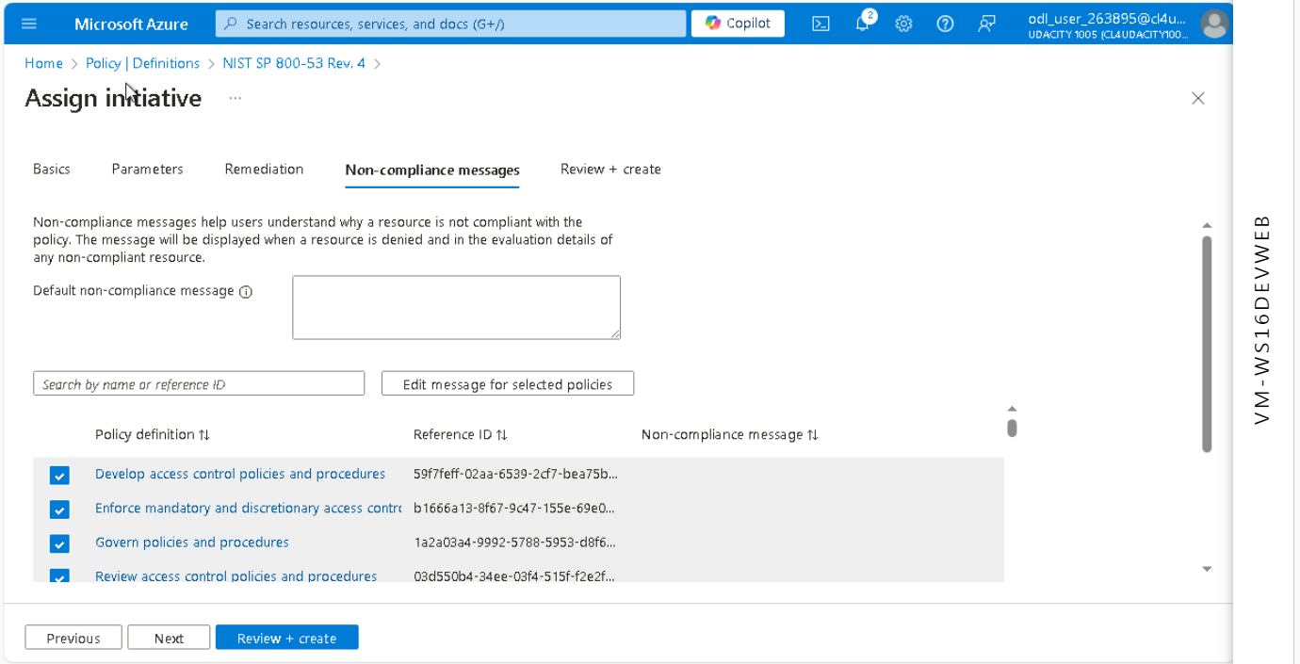

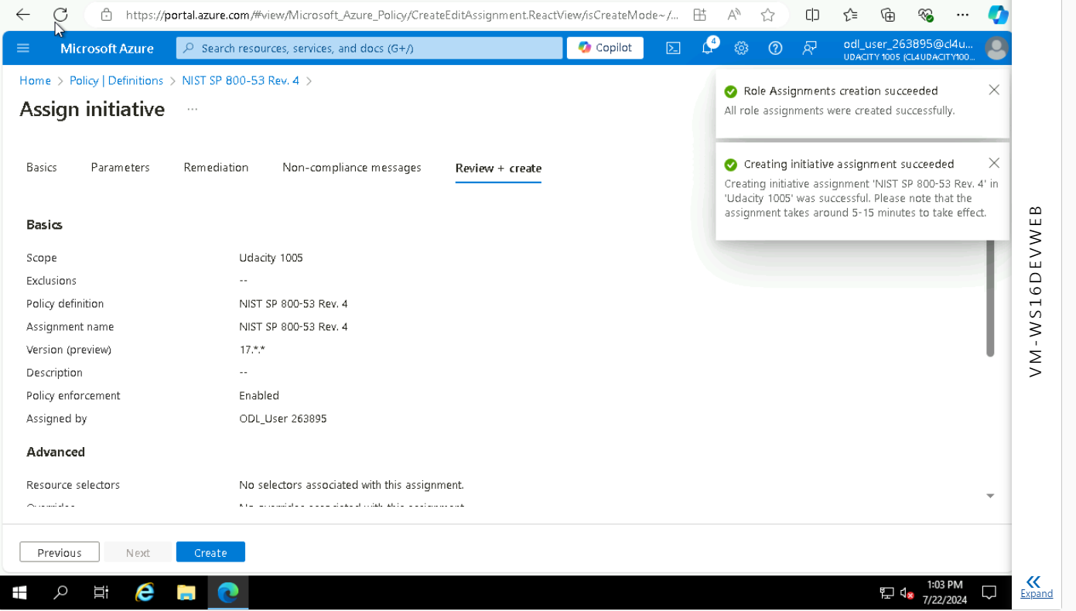

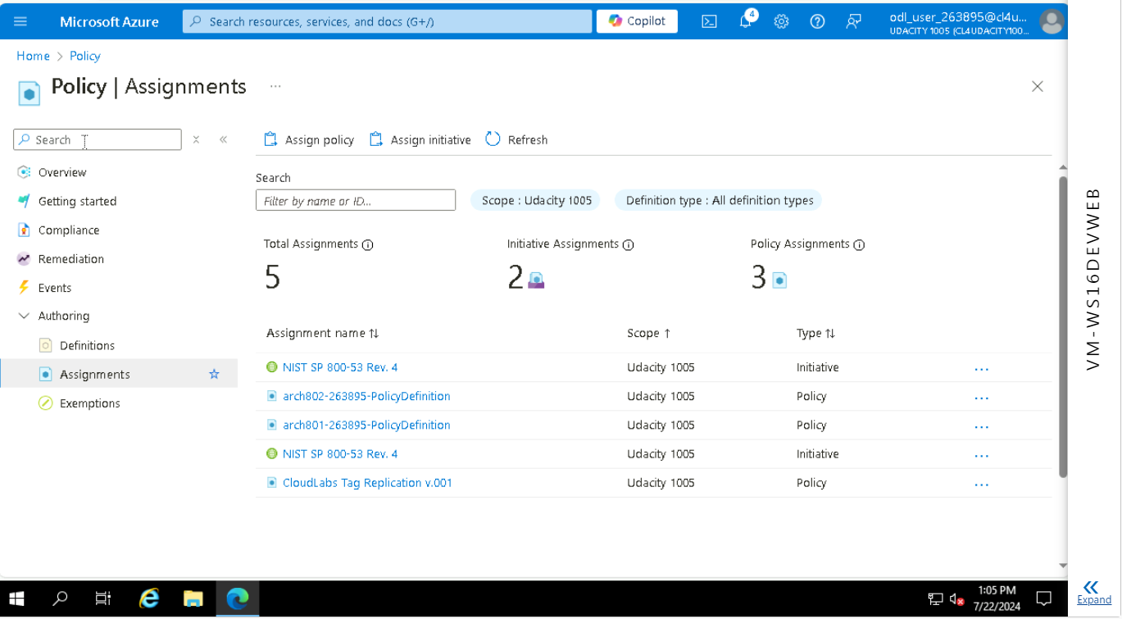

1. **Queries and logs**

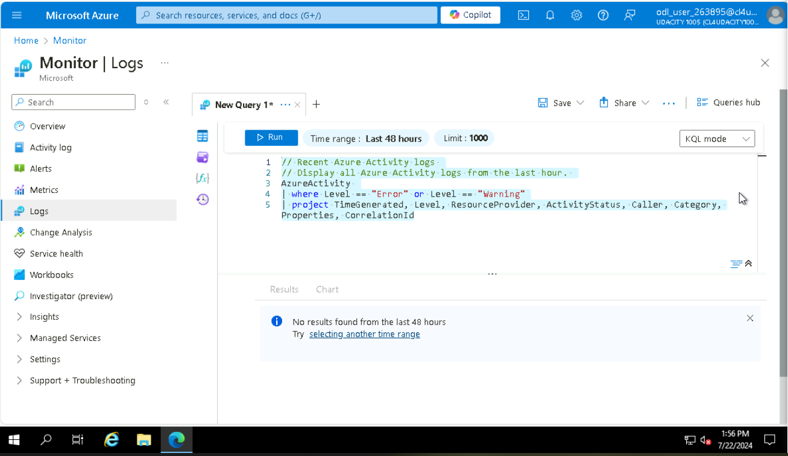

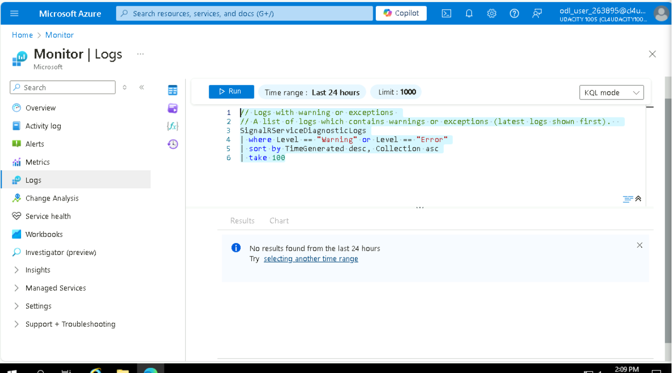

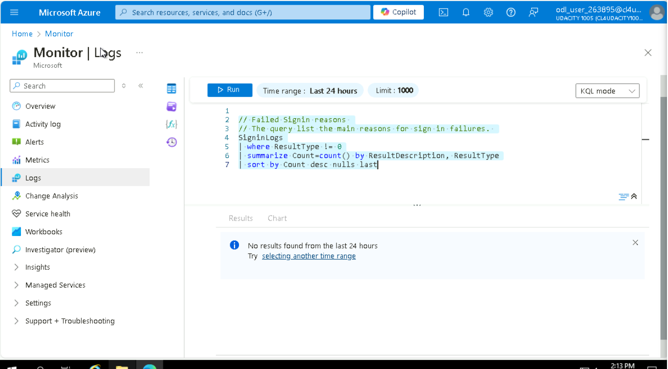

// Recent Azure Activity logs

// Display all Azure Activity logs from the last hour.

AzureActivity |

where Level == "Error" or Level == "Warning" | project TimeGenerated, Level, ResourceProvider, ActivityStatus, Caller, Category, Properties, CorrelationId

No results found from the last 48 hours Try selecting another time range

// Logs with warning or exceptions

// A list of logs which contains warnings or exceptions (latest logs shown first). SignalRServiceDiagnosticLogs |

where Level == "Warning" or Level == "Error" | sort by TimeGenerated desc, Collection asc | take 100

No results found from the last 24 hours Try selecting another time range

// The query list the main reasons for sign in failures. SigninLogs ***** No results found from the last 24 hours Try selecting another time range

SignInLogs|

where ResultType != 0 | summarize Count=count() by ResultDescription, ResultType | sort by Count desc nulls last

No results found from the last 24 hours Try selecting another time range